Brochure Edits 06/05/20
Title page 1:
- The logo looks it’s been cut out? There are dotted lines at the top and bottom of the door. Can you please use the logo I have uploaded in the brief, not cut it out from somewhere else.


Page 3:
- 6008PSQ door, you can still see the blue background on the left and right hand sides
- Please place 6008PSQ as the first door to follow numerological order
- 6003ISQ door still has shadowing on the right , please fix
- On all Ranges: The space between doors is unequal, please make spaces equal between all doors on all ranges
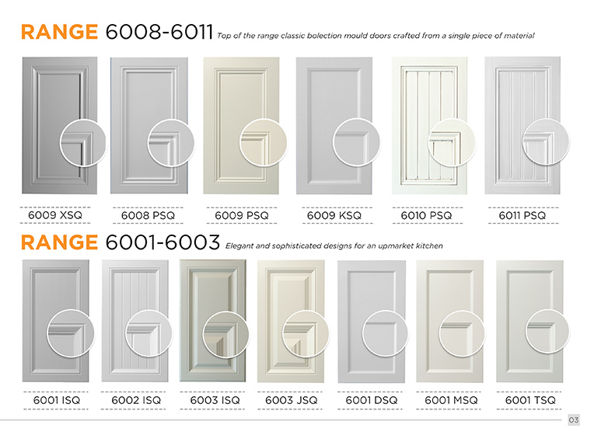
Page 4:
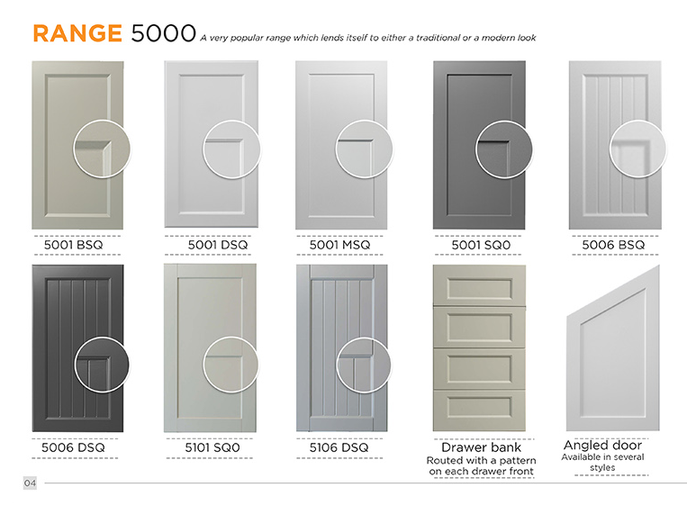
- 5006BSQ close up is too blurry, please fix
Page 5:
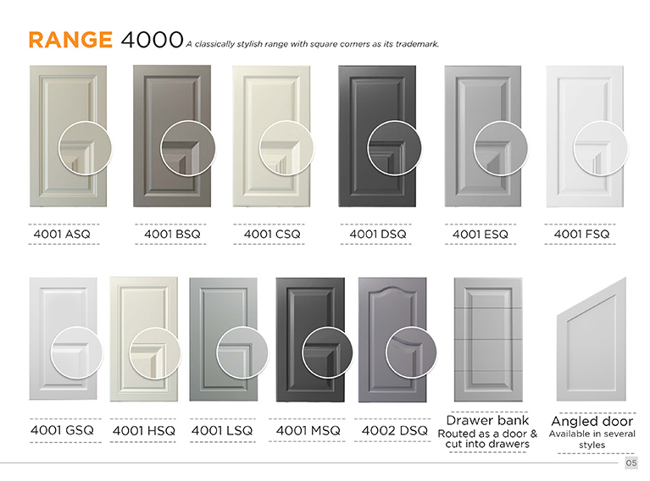
- Please change the angled door on this page back to the old one.
- Is there any chance you can make the doors larger on the bottom row
- Make spaces between all doors in each row, equal
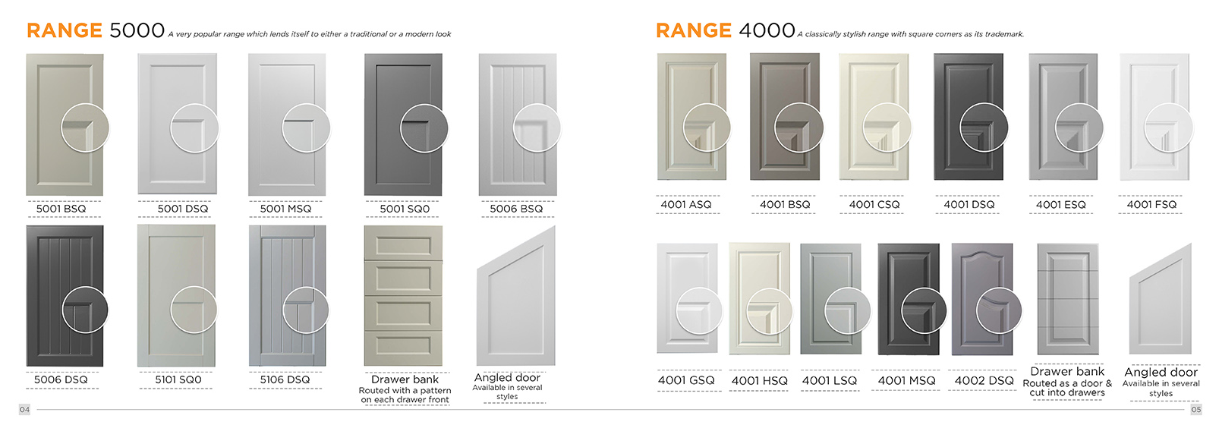

- Please move the top row of doors on page 5 up to the blue line

Page 6:
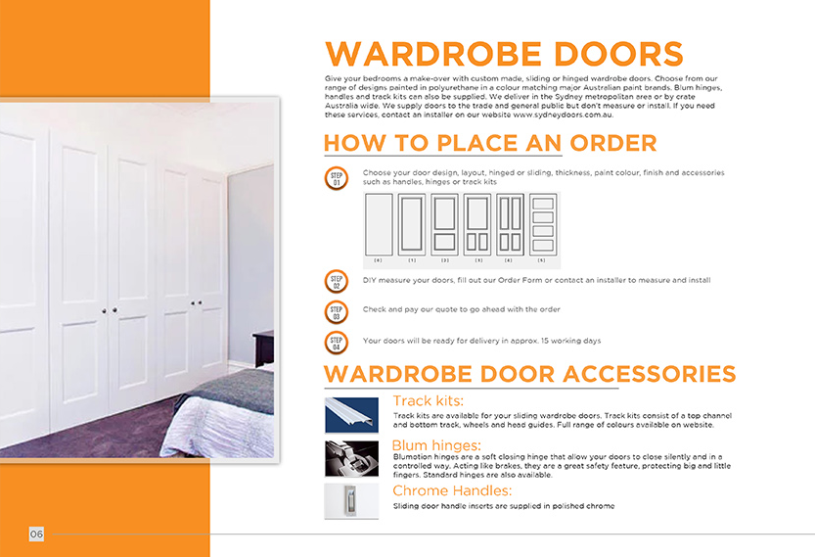
- You need to crop out the track kit and place it on off white background not leave the blue background
- The font size of the text in the Steps is still too small. Increase the font size of “Choose your door design…, DIY measure your doors…., Check and pay…, Your doors will be ready…” to the same size as the text of the steps on page 2.
- Line space between heading: “Blum hinges” and text below it is too small. Make it equal to the line space of Track Kits and Chrome handles.

Page 7:
- Please make the doors in the handles range bigger. To do this, decrease the size of the edges on the bottom of the page. Decrease the space between these doors.
- The side handle close up looks like it’s just showing a circle around the current door. Please fix this
- Shark nose close up needs to be rotated 180 degrees so it is pointing down not up
- Z handle close up needs to be closer as it looks like you’re showing the front of the door.
- Decrease the space between the “Range Handles” heading and the text “A sleek and innovative design for simplicity”. Increase the font size to match other ranges. Do this for the text following the heading Range 1000 and 2000.
- Add a Heading “EDGES” in orange. Delete the text: Edges Design Available: Free edges*”. Below “*Pencil round” add in small text: “*Free edges with any door design”
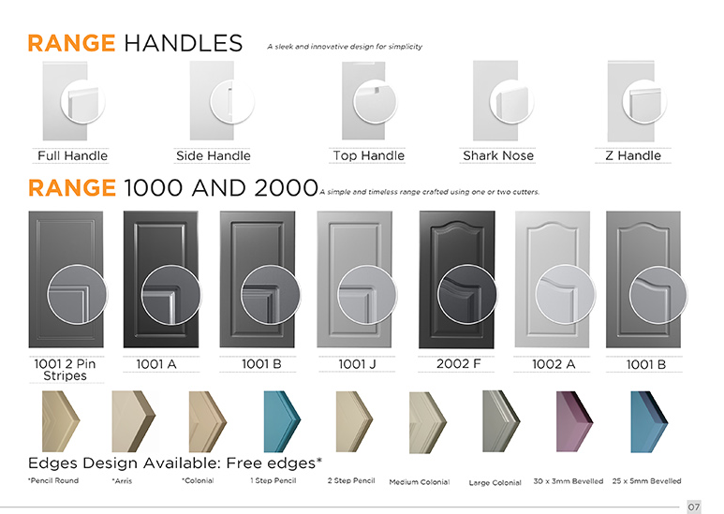

Page 8:
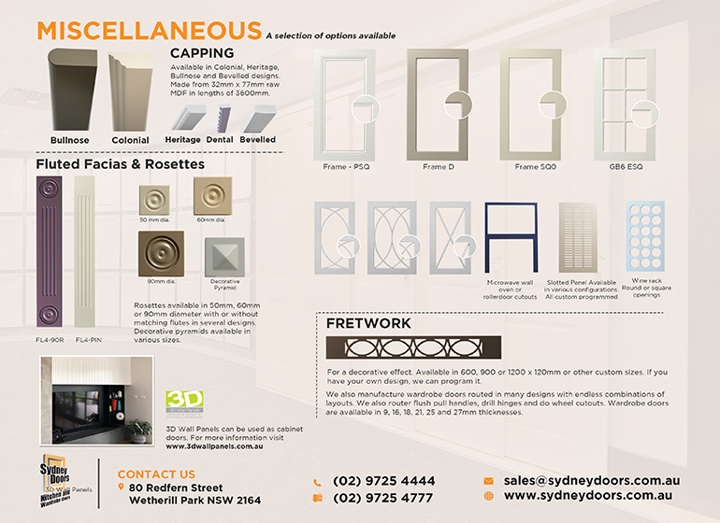

- Delete “Miscellaneous” Heading and delete text. Change to: “FRAMES”
- Put first 8 frames across the top of the page and enlarge to be the same size as other door ranges. Add the names to unnamed frames: Frame Double Arc 1, Frame Double Arc 2 and Frame X. Change text of the 8th frame to: “Microwave, wall oven frames”
- Increase the size of the close up circles to the same as on other doors.
- Increase the Slotted panel and Wine rack to same size as other doors.
- Move Capping. Change heritage, dental and bevelled capping to be the same size and angle as the bullnose and colonial. Show dental last.
- Delete the sentence: “Available in Colonial, Hertitage, Bullnose and Bevelled designs.” Add to the end of sentence “Made from 32mm…. in lengths of 3600. Dental in 2400mm”.
- Delete “Fluted facias…” heading and add heading in orange: “Flutes, Rosettes & Fretwork”
- Delete the sentence: “Rosettes available in 50mm, 60mm or 90mm diameter…. In several designs”. Change to: “Rosettes are available with or without flutes. Flutes available in several designs.”
- Move the Fretwork and 2 sentences below it to under the Rosettes.
- Delete the text: “We also manufacture wardrobe doors routed in many designs... 27mm thicknesses.”
- Add orange heading: “3D Wall Panels”. Increase the size of the 3D wall panels logo.

