Brochure Edits 06/04/20
Please read carefully and make changes as required:
- The back cover should be page 8. Please include our contact us information on page 8 at the bottom.

APPLY TO ALL DOORS
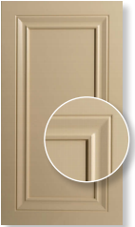
- As mentioned before, the close ups inside this circle needs to be magnified and even. Please make reference to the images I have attached from our old brochure.

I would like it to look this magnified and have the close up this large so that the details can be seen.

- Please also note how all the close up shots are in line and cropped from the same corner and magnified the same. I would like to see this for the new brochure. At the moment, the close up shots do not look uniform nor are they aligned.
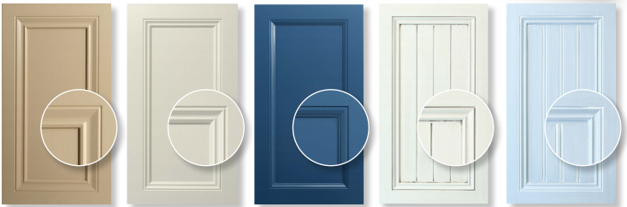

Page 3:
- Top row of doors should align with bottom. Make 6011 PSQ right edge align with 6001TSQ right edge.
- 6009 KSQ is not aligned with the other doors (it looks higher than the rest)
- 6001 TSQ is not aligned with the other doors
- 6003 JSQ top corner of door is missing
- 6001 MSQ has a shadow to the right of the door

Page 4:
- In the white space, I’m thinking to put this message regarding the different door shapes.
“Some door designs are available in other shapes, please enquire.”
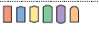
- Put 5006 BSQ in the top row and move bottom doors to the left, leave a space for a (yet to be supplied) photo of a 5000 angled door as the last door in the row.

Page 5:
- Please move 4001LSQ to the bottom row so it’s even. Ensure spacing between all doors are even and the top and bottom rows align.
- Drawers to be 2nd last image and angled door to be the last image on the bottom row

Page 6:
- This was not the text I sent to place on this page. Please delete the paragraph and include this text as provided before:
“Give your bedrooms a make-over with custom made, sliding or hinged wardrobe doors. Choose from our range of designs painted in polyurethane in a colour matching major Australian paint brands. Blum hinges, handles and track kits can also be supplied. We deliver in the Sydney metropolitan area or by crate Australia wide. We supply doors to the trade and general public but don’t measure or install. If you need these services, contact an installer on our website www.sydneydoors.com.au.”
- Please include this image under step 1 of order process (it has previously been included but deleted for some reason)
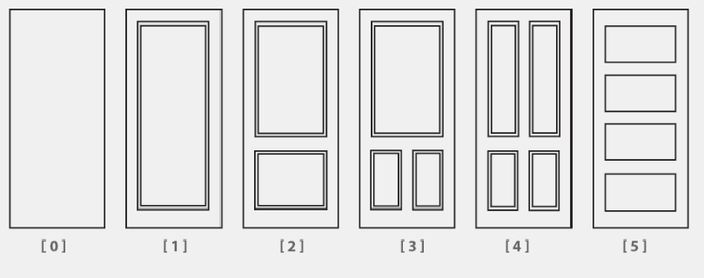

- Make the images of the wardrobe accessories bigger.

- Wardrobe tracks should have photos of the tracks, not hinges. This photo is to be provided at a later day once photographed.

- Please change the blum hinges to the hinge image, not the wheels. Also to this paragraph please add at the end: ‘Standard hinges are also available.’

- Chrome Handles: Centre the photo and make bigger.

Page 7:
- Get rid of the : after range 1000 and 2000
- Please delete 1006A and insert 2002F
- Please note ‘range Handles’ will have new doors photos and will have a total of 5 doors with text, for now you can keep it as is but I will need space for these 5 doors and their design codes.
- Edge Designs Available not Edges designs (place this at the top- not under the photos).
- Please add an asterisk to the free edges: Pencil, arris and colonial

Page 8:
- I have only asked for FL4-90R and FL4-PIN photos to be included. Please delete all the other fluted facials. This will give you more space so that you could fit in our contact info on this last page. Perhaps put Fluted facias and rosettes together
- More frame photos to be provided
- Delete the “Choose your design page”, page 8 is the back cover of the book.

Please remember to colour match the doors and accessories to ensure the theme is consistent. So please change the Fretwork, Fluted facial, capping and microframe colours.

