Back page:
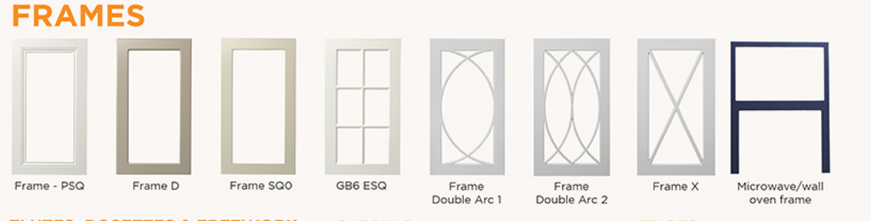
Evenly space all frames

EDGES:
- Crop white background from all edge images
- Delete all * from all edges.
CAPPING:
Make Bullnose and Colonial capping images the same size and scale as the Heritage and Bevelled capping. They are all 32mm x 77mm.

Crop bathroom image as previously advised.
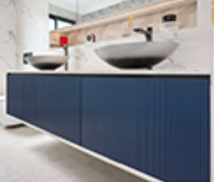

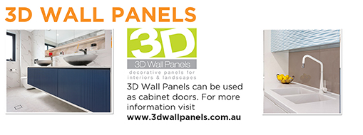
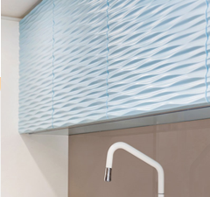

Crop front page as previously advised.


Page 03: Delete , after design 6001TSQ

All ranges: Make enlargements in circles the same zoom in as previously advised.
Some enlargements look blurry.

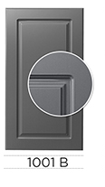
Design 1001 B - the side of the door is visible in the close up - zoom out a little more.

