Brochure Edits 09/04/20
Please read carefully and make the changes required:
Page 3: Please refer to this photo again from the old brochure. I have asked for these changes many times. You need to align all the top of the door designs in the close up with the 180 degree line I drew.
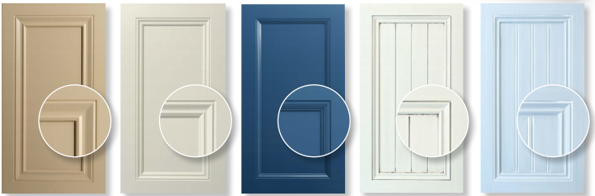
- Door 6009XSQ: The close up shot is too high up, every door in that row has some space in the right corner. Please fix.
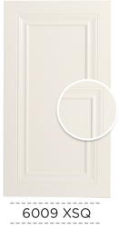
- 6009KSQ: This one has too much space, the corner of the door design is no where close to the corner of circle like the other photos. Please fix.
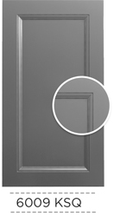

-6001TSQ: the close up is too high up, move it down to line up with the door next to it. When you look at it, the designs are not even.. Please check this as I keep asking and nothing gets changed
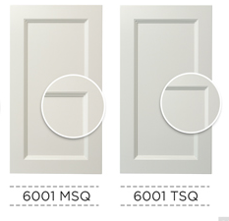

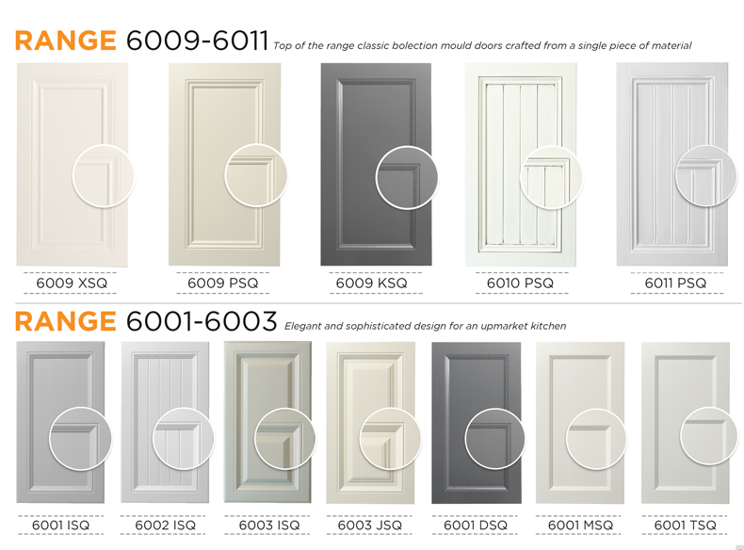

Page 4:
Make the door design codes larger like on page 3
5001MSQ: The corner needs to be moved up and to the right. Does not match the doors next to it
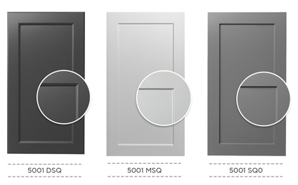

- Remove the close up for drawer bank and angled door
- Delete , at the end of front in the drawer banks

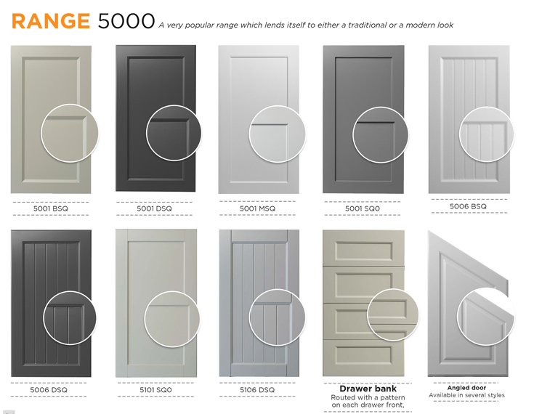

Page 5:
- Make the door design codes larger like page 3
- Remove close up of Drawer Fronts and Angled Doors
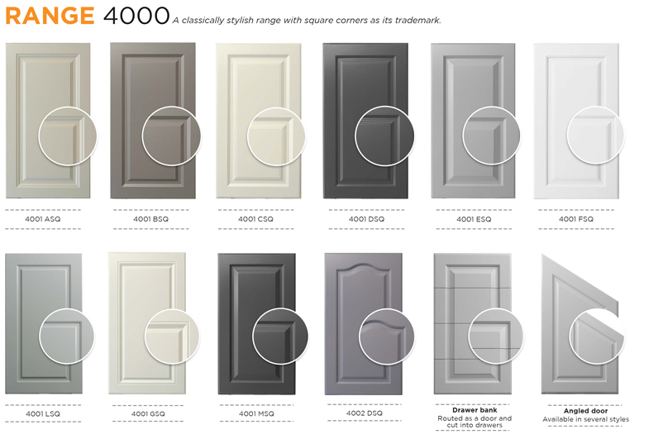

Page 6:
- Do not hyperlink and underline website. Should be normal black text
- You deleted the how to place an order steps? This still needs to be in there. Please add it back and as I have asked the door layout image should be UNDER Step 1.
- The wardrobe door accessories can go back to where it was. Change the text of Chrome Handles to: “Sliding door handle inserts are supplied in polished chrome” This should be on one line.
- I noticed the white space between each page is different. This should be the same for every single page. Therefore spread the doors in range 5000 out more.

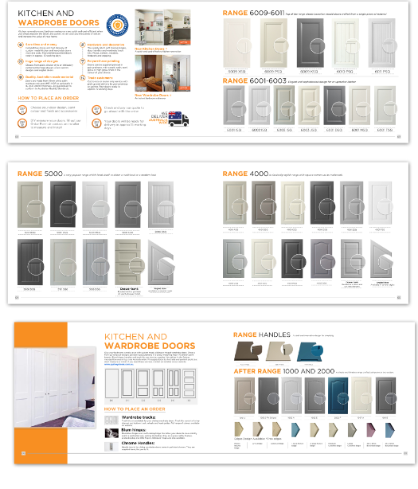

- Decrease the size and crop part of the right on the wardrobe door larger photo to make more room for text
- Wardrobe door accessories should have a title on top of wardrobe door tracks “Wardrobe Door Accessories”
- In the top paragraph after the website, add: Please refer to our wardrobe doors page on the website for more information.
Page 7:
- Put asterisk on pencil round edge, arris and colonial
- Make the design codes text bigger like on page 3
- Make the close up circle bigger like on the rest of the pages, 3 ,4 5
- 1002J, 1002A, 1007A and 100AB have a shadow at the top? Are you using the images I attached to rhe brief or are you taking them from our old brochure. Please use the higher quality images I send to you through the brief. There should be no extra shadow.
- The image quality is very blurry, please fix this.
- Delete After in the title, Should just be ‘Range 1000 and 2000’
- Decrease the sizes of the edges since we need more space for new photos.

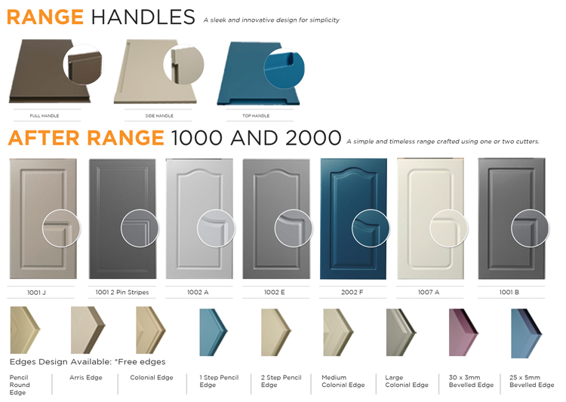

Page 8:
- Remove the white background around the frames
- Why are there still so many flutes? I asked to remove this last time
Only keep:
- FL4-90R and FL4-PIN (Delete the rest)

