Brochure edits 25/08/20
Page 8:
- Replace the capping with this photo I uploaded to brief. Please make sure the size of the photo is appropriate for the page.

Page 3:
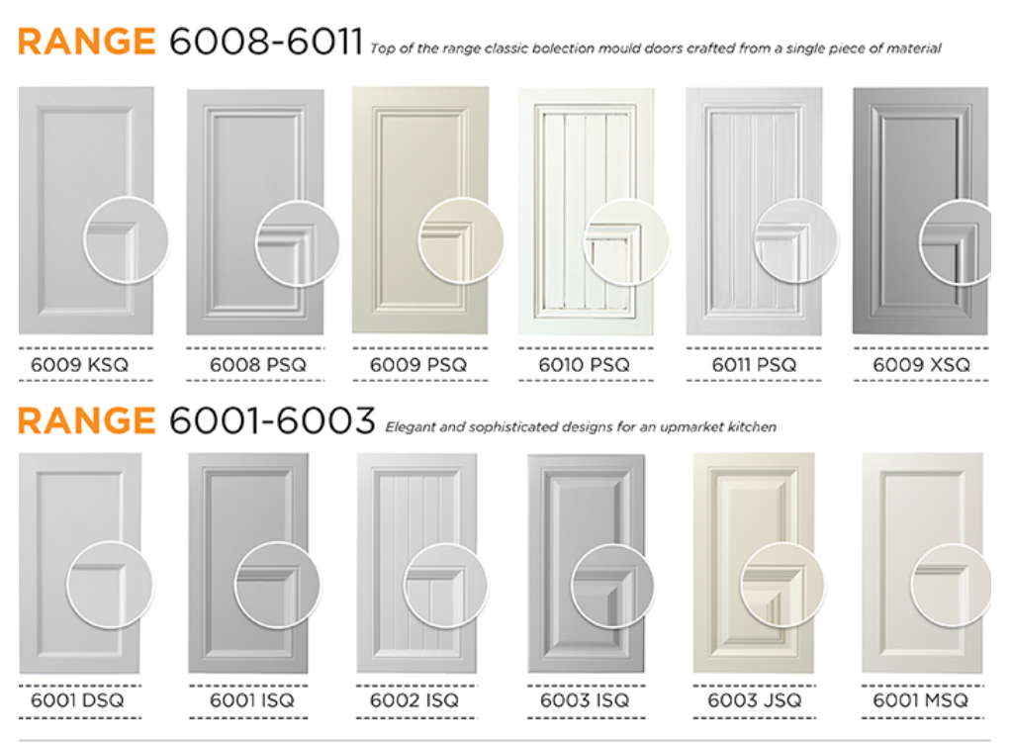
- Please look over this edit again. It was not followed in the last edit. Some of these design codes start on the 3rd dash while other start on the 4th. You need to make it the same for all. 3rd dash starts marked in blue and 4th dash starts marked in red. Please fix for all design ranges on this brochure.

Page 5:
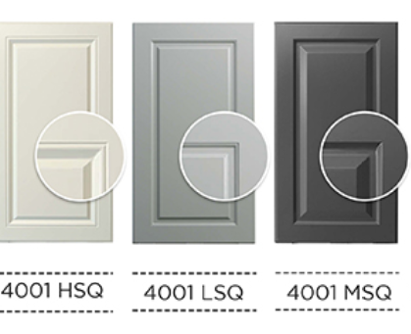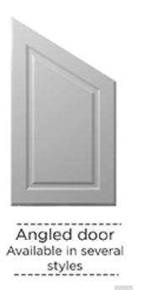
- 4001MSQ top line is still light and so is top and bottom line of ‘Angled Door’. Change to black and bold please.
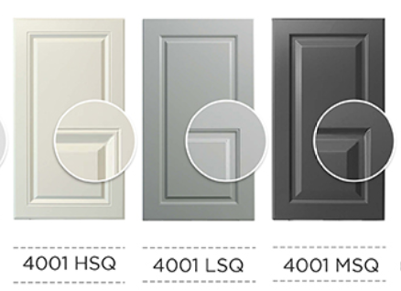
- 4001HSQ heading is too high, please align. (fix this, I asked in the last edit, it’s still too high)

Page 7:
- Can you please zoom in on the enlargement of the Side Handle? At the moment it just looks like the door has 2 handles that are not equally placed. The enlargement needs to be more like that of the Top Handle. Make it look something like this in the circle please.

