Please follow the same layout as page 1 and 2. Please remember to change the door colours to hues of white like page 1 and 2.

Page 3
Range 5000
A very popular range which lends itself to either a traditional or modern look

Please place doors in this order
5001BSQ
5001DSQ
5001MSQ
5001SQ0
5006BSQ
5006DSQ
5101SQ0
5106DSQ
Individual Drawer Fronts
Place this text below: Routed with a pattern on each drawer front (similar to layout in screenshot below)
Angled Shaker (photo to be provided at later date- awaiting finish production)
Available in several styles for storage cupboards under stairs or raked ceilings.
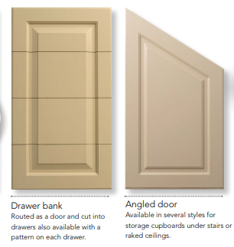

Page 4
Range 4000
A classically stylish range with square corners as it’s trademark.
4001ASQ
4001BSQ
4001CSQ
4001DSQ
4001ESQ
4001FSQ
4001LSQ
4001MSQ
4001GSQ (photo to be provided later date- awaiting finish production)
4002DSQ
Drawer bank routed as door
Place this text below: Routed as door and cut into drawers

