Brochure edits round 2:
Front cover:
- The ceiling still looks like its 2 different colours. Although it is not as yellow as it was previously, this needs to be uniform. Please change it all to the super white colour near the window (I have circled what I want the rest of the ceiling changed to)
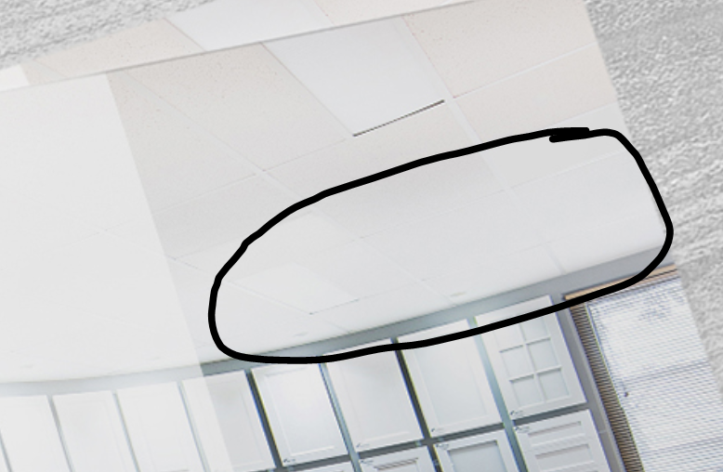

Page 2:
- The guaranteed symbol can be a little bigger and needs to be a circle, right now looks more oval.
- Text under heading should save ‘It can save you’ not ‘it can saves you’
- The icons need to be in this order. 3 on the left and 3 on the right. Please make sure all the icon align so it fits and looks like a perfect square. There are some text changes so please fix this as listed below.

(left hand side)
Same time and money
Competitive prices and fast delivery of customer made kitchen and wardrobe doors Australia wide. Polyurethane painted doors ready in approx. 15 working days.

Huge range of designs
Choose from plain, shaker style or intricately patterned heritage design, even custom designs and angled doors.

Quality Australian made material
Doors are made from 18mm white satin moisture resistant (MR) MDF or optionally in 16, 21 or 25mm thickness. All guaranteed to conform to Australian Quality Standards.

(right hand side)
Hardware and decorative
We supply Blum soft closing hinges, door handles and wardrobe track kits. Flutes, corbels, rosettes, fretwork and capping.

Polyurethane painting
Doors can be supplied painted in polyurethane, with a matt, satin, semi gloss or high gloss finish in the colour of your choice.

Trade customers
Cut to size or router only service with pick up and delivery to your premises or painter. Raw doors ready in approx. 5 working days.

- The before and after images doesn’t look any bigger and to remove the round circle in the second wardrobe before and after image and add a white line in the before and after first image to separate the photo. The white line can be abit bigger for both photos but lease make sure to make it bigger. You could move the 2 columns of icons closer together if need be.
- Delete the ‘.’ After makeover in bottom before and after image
- I think we should really list the words “step 1 .. step 2” inside the circle. Please delete the icons

Page 3:
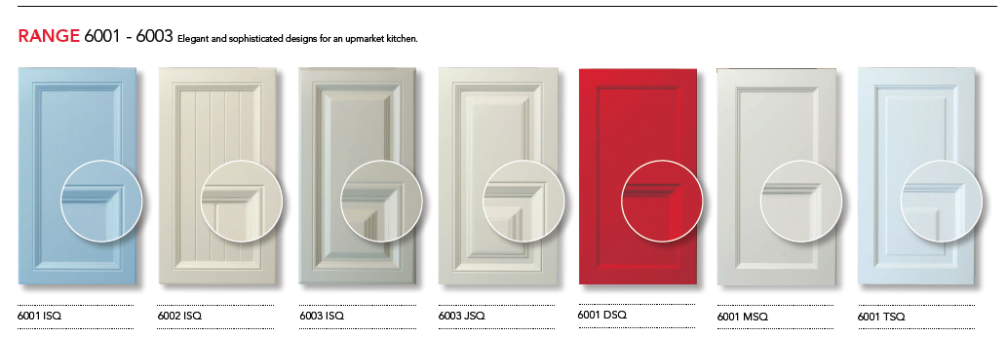
- I want these doors to be bigger. I have included my old brochure please copy this layout for the doors, you can move the close up circle closer inside the door to make more space to expand the doors.

