Brochure Edits 30/3/20
NOTE: APPLY ALL DOORS
All close ups inside the circles are to be magnified more e.g. 2 x as they currently look like the original size. All close ups to have the outside edge of the profile to be in the same position, e.g. aligned with the outside of the door or at least all in the same position..
Align the outer edge of the close up profile with the outer edge of the door on all designs
The close up should look like this in the circle, make sure it is lined up the same!


Page 2:
Page 2 (inside cover) show the full wardrobe door in the After image. Currently it is cut off.

Renumber the page to page 2, not page 1

Page 3:
Align the left and right side doors of 6009-6011 with the range 6001-6003.

Renumber the page to page 3, not page 2
6003JSQ, 6001DSQ and 6001TSQ circles need to move slightly down to be aligned with the others in the row

Page 4:
Renumber the page to page 4, not page 3
Make Range 5000 drawer bank image the same size as the other doors and make it the 2nd last image on the bottom row. The text should read: Routed with a pattern on each drawer front. (Delete the rest of the text).

The new painted angled door (5001 design) should be the last image on the bottom row. (Image to be provided) On the Angled doors text to read: Available in several styles (delete the remaining text.) This will allow you to increase the size of all the doors so there is not a large white space beneath them.

Range 5000 uneven spacing between doors and check all doors are the same dimensions as the height of the doors is not equal. E.g. 5001 BSQ and 5001 DSQ are shorter than the others. Align the top of the doors, also on Range 4000 doors.

Page 5:
Renumber the page to page 5, not page 4
Remove the corner 4001DSQ
Remove 4003GSQ
Page 3 and 4, delete all text from footers except page numbers.

Range 4000: the space between 4001 FSQ and 4001 LSQ is too big compared to the other spacing.

Delete the partial door on the edge of the page (right hand side).

Change the drawer bank text to “Routed as a door, cut into drawers. Delete the remaining text.

Page 6:
Renumber the page to page 5, not page 4
The first paragraph of text, move the website to a new line.
I think the title should say ‘How to order wardrobe doors?
I think the layout should go under step 1? Right now it doesn’t relate to anything.
On the Wardrobe doors page: Add pics of a set of tracks, Blum hinge and a chrome handle with some caption text (from website).

Wardrobe tracks: Track kits are available for your sliding wardrobe doors. Track kits consist of a top channel and bottom track, wheels and head guides. Full range of colours available on website.
Blum hinges: Blumotion hinges are a soft closing hinge that allow your doors to close silently and in a controlled way. Acting like brakes, they are a great safety feature, protecting big and little fingers.
Chrome Handles: Handle inserts for sliding wardrobe doors come in polished chrome. They are supplied loose, for you to fit.

Page 7:
Please place doors in this order on one page
Range Handles: A sleek and innovative design for simplicity
Full Handle (photo to be provided)
Side Handle (place photo upright)
Top Handle (photo to be provided)
Shark Nose (photo to be provided
Z Handle (Photo to be provided)

Range 1000 and 2000: A simple and timeless range crafted using one or two cutters.
1001J
1001 2 Pin Stripe
1002A
1002E
2002F
1001A
1001B
On this page please include the edges images as well. Similar to this one
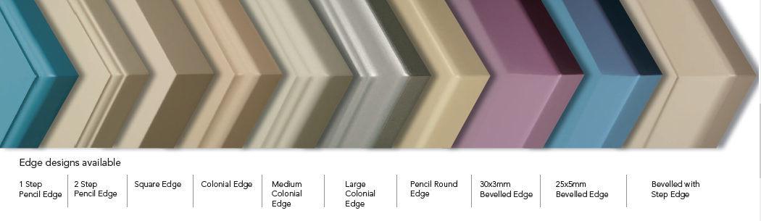, please include the edges in the order below.

Edges Design Available: *Free edges
Pencil Round Edge *
Arris Edge *
Colonial Edge *
1 Step Pencil Edge
2 Step Pencil Edge
Medium Colonial Edge
Large Colonial Edge
30 x 3mm Bevelled Edge
25 x 5mm Bevelled Edge

Page 8:
Miscellaneous: A selection of options available. (Please refer to last page on old brochure for ideas)
PLEASE PLACE THESE ON THE LEFT SIDE OF PAGE
Capping: Available in Colonial, Heritage, Bullnose and Bevelled designs. Made from 32mm x 77mm raw MDF in lengths of 3600mm.
Colonial
Heritage (Photo to be provided)
Bullnose
Bevelled 30 x 3mm (Photo to be provided)

Fluted Facials
FL4-60R
FL4-PIN

Rosettes: Rosettes available in 50mm, 60mm or 90mm diameter with or without matching flutes in several designs. Decorative pyramids available in various sizes.
50mm dia.
60mm dia.
90mm dia.
Decorative Pyramid

Fretwork: For a decorative effect. Available in 600, 900 or 1200 x 120mm or other custom sizes. If you have your own design, we can program it.

PLACE THE BELOW IN MIDDLE/LEFT SIDE OF PAGE
Frame PSQ
Frame D
Frame SQ0
GB6 ESQ
X Frame (Photo to be provided)
Double Arc 1 Frame (photo to be provided)
Double Arc 2 Frame (photo to be provided)
Microwave Wall Oven
Wine Rack: Round or square openings
Slotted Panels: Available in various configurations. All custom programmed.

I would like you to also include a note somewhere on this page, so that people can see, maybe at the bottom?

Some door designs are available in other shapes, please enquire.
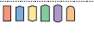

T

