Brochure edits 24/8/20
Page 8:
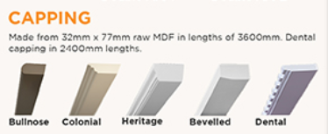
- Please make bullnose capping a little wider, it is a little too short at the moment.
- Make the capping look like this photo, the ends of each capping is nice and square not slanted especially bullnose and colonial.
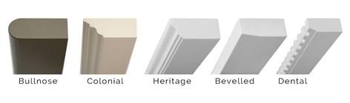
Page 5:
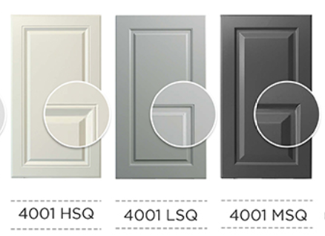
- 4001HSQ heading is too high, please align.
Page 7:
- Can you please zoom in on the enlargement of the Side Handle? At the moment it just looks like the door has 2 handles that are not equally placed. The enlargement needs to be more like that of the Top Handle.

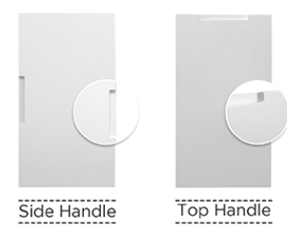
Page 6:
Design Ranges on this page: The design codes marked with vertical lines start on the 3rd dash whereas all other codes on this page start on the 4th dash (please centre the design codes left to right).
Design Ranges on all other pages have codes start on the 3rd dash. Please centre all the design codes of all ranges.

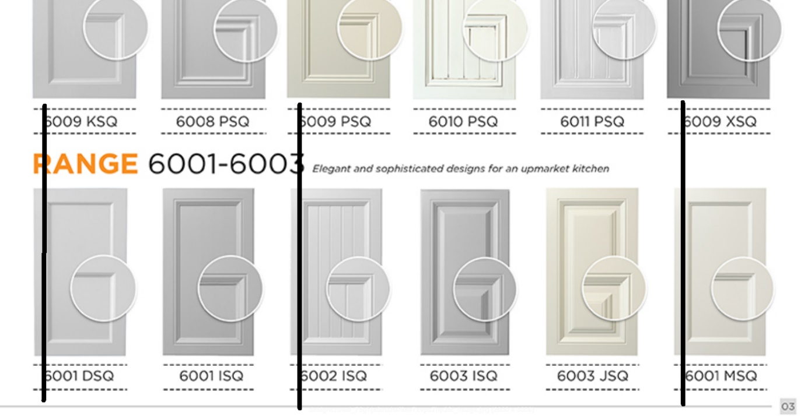

Range 4000 has light grey dashes above and below the design codes, all other ranges have black dashes above and below the design codes. Please make the dashes all the same colour.

