Brochure Edits Round 3

Front page:
Please opaque out the glass section of the showroom window, as there is distracting background scenery that might not look good when printed
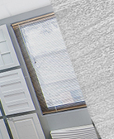

Page 2:
- Guaranteed symbol still looks abit oval to me, please make this more rounder like a circle please.
- Under the save time and money: Should be custom made doors not ‘customer made’
- I still want to see more of the right hand side of the before and after kitchen. Please make the images larger. I’m sure the icon text can be condensed a bit more.

Page 3:
- The bottom row close up door photos seems to have white space , it’s not cropped in the same area for the close up shot. Make sure the door is cropped in the same spot.
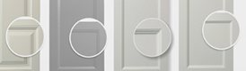
- The circles are all unaligned, some hang out the door while others are inside, please align all circles.

I still want to see more of the right hand side of the before and after kitchen. Please make the images larger. I’m sure the icon text can be condensed a bit more.

