Brochure edits 18/06/2020
Front page: Crop the image as per the crop shown below and photo shop the shadow of cabinet.

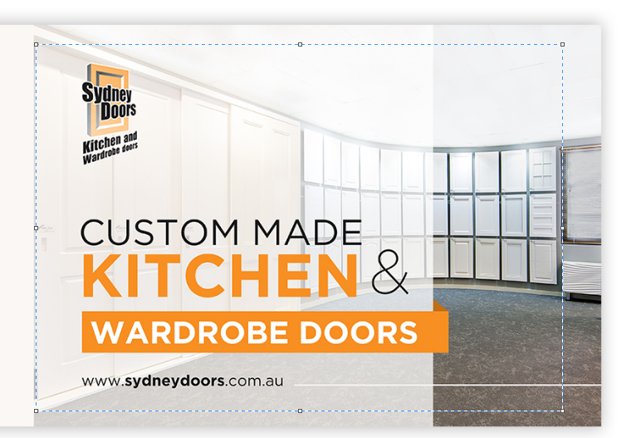
Photoshop out any shadows from the cabinet and window

Back page

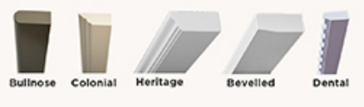

Can you show all the capping images at the same angle?

Align the Fretwork with the FLUTES.. heading.

Delete the wine rack and slotted panel images.

Change the purple flute to a shade of grey (same colours as the doors).
FOR ALL RANGES: Can you order the designs in alphabetical order in each range e.g. 4001 DSQ and 4002 DSQ and 5001 SQ0 and 5101 SQ0, 6008 PSQ and 6009 PSQ etc?

ENSURE ALL CLOSE UPS ARE CLEAR AND AT THE SAME SCALE.

Page 04
Design 5101 SQ0 close up circle – the square edge of the door is visible in the close up - zoom out a little more.
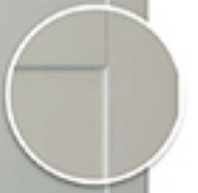
Side of door is visible in close up

Page 05
4001 GSQ appears shorter than the other doors.
4001 HSQ and 4001 MSQ and 4001 FSQ - the top or side of the door is visible in the close up - zoom out a little more.

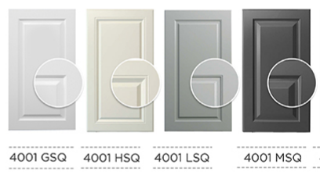
Top of door is visible in close ups HSQ and MSQ
GSQ is shorter than others

Page 03
Design 6001 DSQ - side of the door is visible in the close up - zoom out a little more.

Page 07
Design 1001 B - the side of the door is visible in the close up - zoom out a little more.

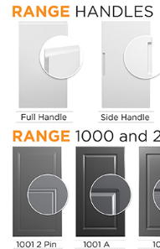
Move Full handle to start in line with heading and space all other doors evenly

Move the Full Handle door so that it is in line with the Heading HANDLES and space the doors out evenly.

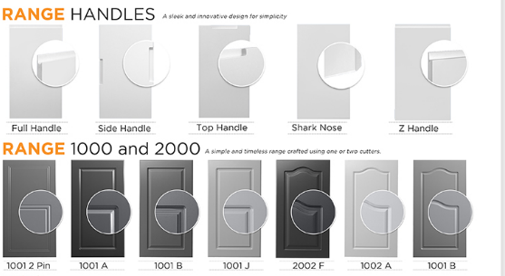
Range Handles - move the close up circles down so that they are in the same position as all other ranges.
1001 B on the end of the line is actually 1002E

Delete all Edges images and edges text from page 07 and insert the Pencil round, Arris and Colonial images only on the back page in the space where the Wine Rack and Slotted panel were. Include the Heading “EDGES” and the text: “Pencil round” “Arris” “Colonial” below each image. Delete the text: “Free edges available with a design” and all the “***”
(You may need to move the Capping and 3D Wall Panels to the left to create space for this). You can move the edges closer together.


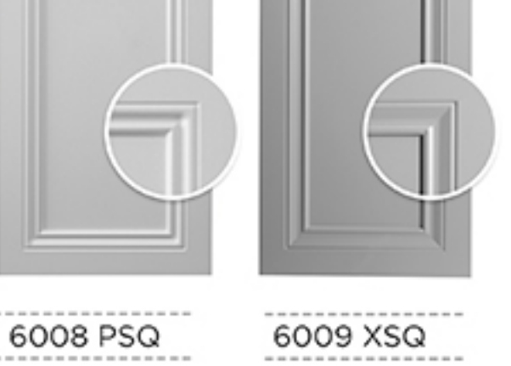
This is a good zoom in. Close up and clear.
This is a bad zoom in. Blurry and unclear
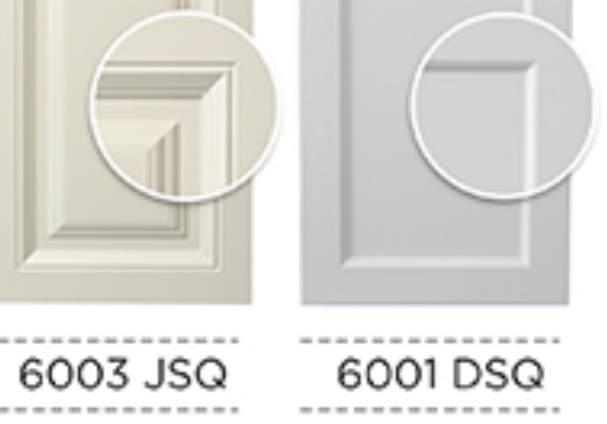
This is a bad zoom in. Blurry and unclear. This zoom is not close enough. Enlarge close up
This is a good zoom in. Close up and clear.
Please make all images of full doors and close ups very clear, not blurry. Ask us for high res images if you don’t have them.

Crop wall panels image closer e.g.
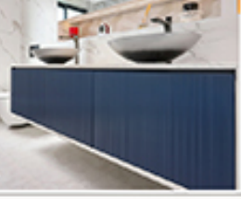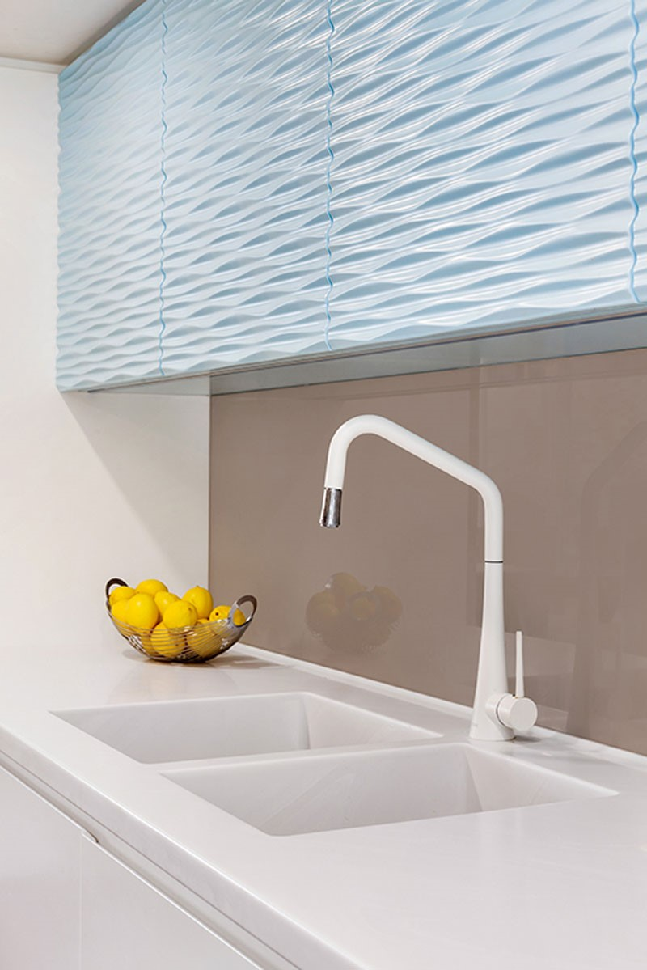
And in the space to the right of the logo add photo

