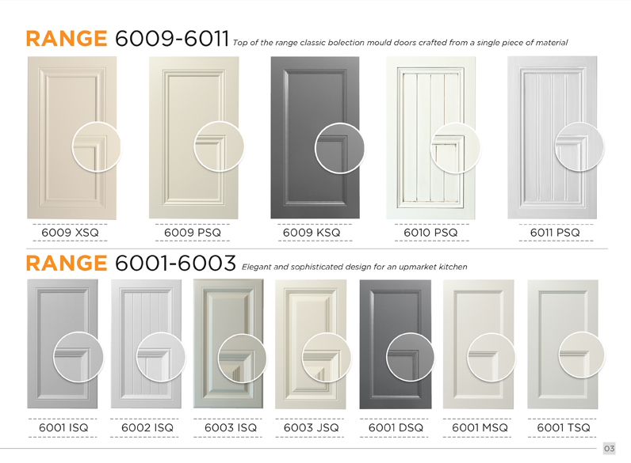
Brochure edits 17/4/20
Page 3: please align the designs in 6001-6003 with the line. 6003ISQ, 6003JSQ, 6001DSQ, 6001MSQ and 6001TSQ are still too low.

Page 4:
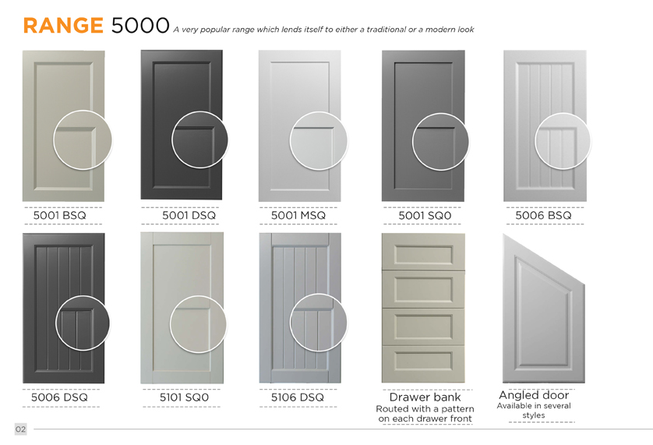
- This should say page 4 not page 2
- The close up circles on this page seem to be bigger on the other pages, can you please make this all one size
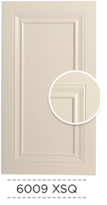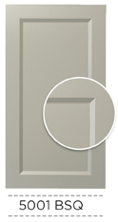

Page 5:
- Should say page 5 not page 3
- These close up circles are so small, the close up in 4001BSQ and 4001ESQ is barely showing. Increase circle size
- Move the close up slightly up
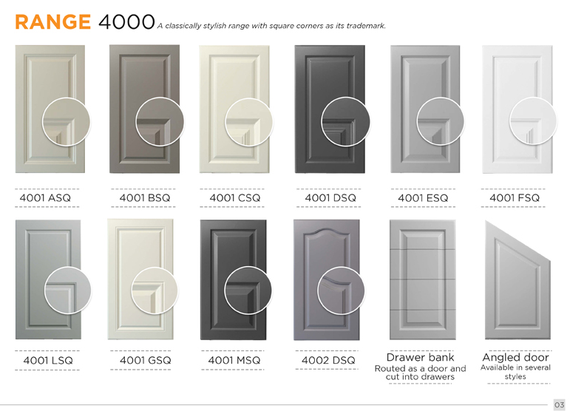

Page 6:
- Wardrobe door accessories should be an orange header like how to place an order
- Please re-add the heading Track Kits under the heading of Wardrobe door accessories in grey and unbolded like the text below it.

Page 7:
The close up circles need to be the same size as 6000 range

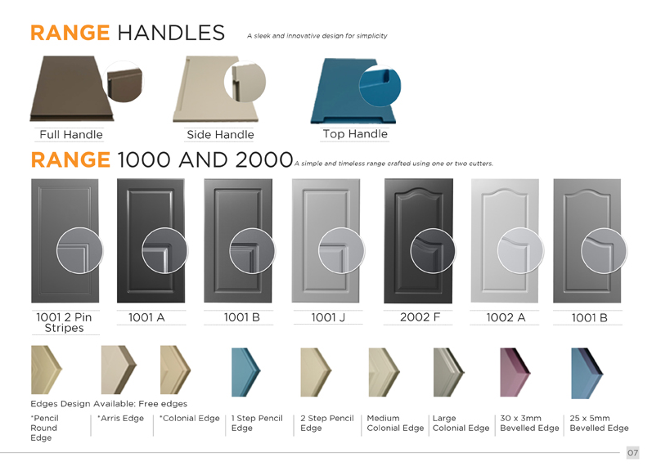
Back cover (page 8):
- Please insert the image uploaded in brief and logo on the page with text: “3D Wall Panels can be used as cabinet doors. For more information visit www.3dwallpanels.com.au”

