Brochure edits 200720

Front page:

Can you photo shop the labels on the doors out? Delete what is inside these circles



Back page:
Put a space between the words “Dental capping” and “in”, not “ Dental cappingin”

Add a fullstop at the end of this sentence: “Flutes available in several designs“ e.g. “Flutes available in several designs.”

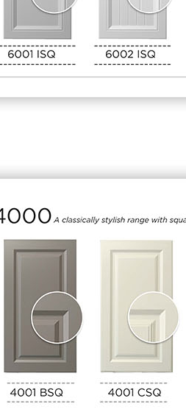
Make the dotted lines above and below the range name the same width as the door. On range 4000 the dotted lines are too short.

Delete the first and last “-“
Make the dotted lines the same width as the door.
Make the dotted lines above and below the range name (e.g. 6001 ISQ) the same width as the door on all ranges. On most ranges, the dotted lines are too long.

Make the colour of the dotted lines on all ranges, like the 4000 range.

Page 06

Track Kits: Add a fullstop after “Full range of colours are available on our website” E.g. “Full range of colours are available on our website.”

