Brochure Edits 14/8/20
Page 8:
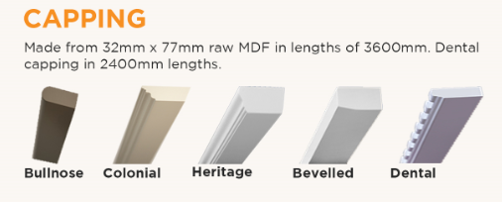
- Can you please make bullnose the same size as the other capping and on the same angle
- Heritage capping looks squashed width wise.

Page 3:
- Heading 6008-6011 “top of the range bolection mould doors crafted from a single piece of material” Is wrong in our existing brochure as that is for 6004 range doors. – What text will we put?
4001 CSQ shorter and 6009 XSQ not squared

Page 7:
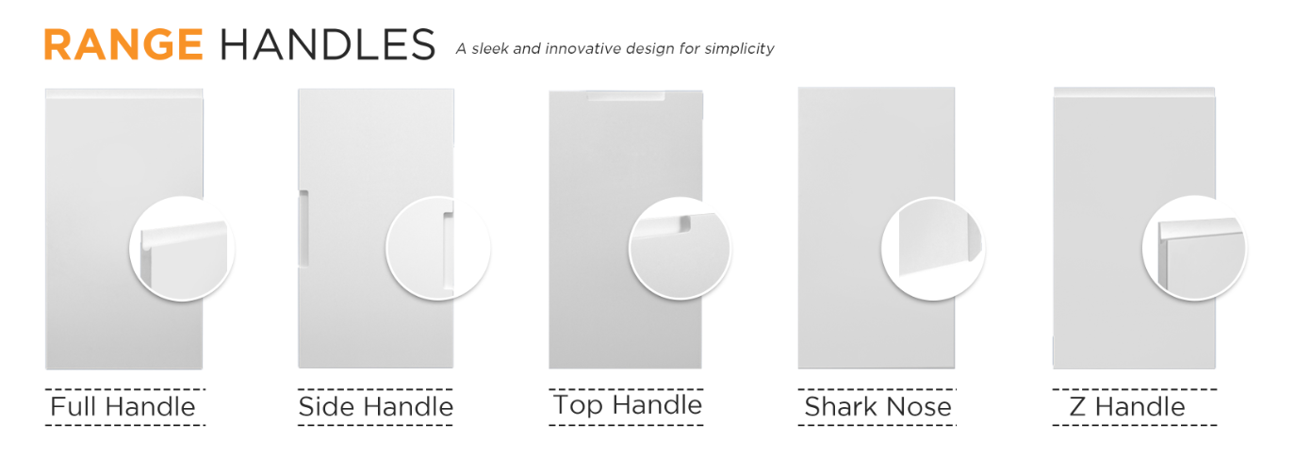

- Please re-crop these doors so there’s no dark shadow as shown in the boxes. Please zoom in to see what I mean.

- Some of the design codes are not centred or aligned 4001 HSQ / 4001 GSQ / 4002 DSQ / 4001 ESQ / shark nose / z handle

- Page 7 font size of handle doors(top row) is larger than font size of the bottom row. See F for full handle next to F of 2002 F.
Page 6:
- Delete comma in first sentence under wardrobe doors heading “Give your bedrooms a make-over with custom made sliding or hinged wardrobe doors.”
- Please change text under Chrome Handles to: Sliding door handle inserts can be supplied in satin chrome.
Page 2:
- Under step 1, fix text to say: Choose your door design, paint colour, finish and accessories

Page 4:
- Drawer bank text below heading is bigger than angled door heading, can we please try make them the same for both page 4 and 5
Page 5:
- Replace the & with a comma: ‘routered as a door, cut into drawers’

Page 6:
- Put a fullstop ‘.’ After website under track kits heading. “…. Full range of colours are available on our website.”
- First paragraph under heading of Wardrobe doors change this sentence “choose from our range of designs painted in polyurethane in a colour matching major Australian paint brands.” to this one please: “Choose from our range of designs painted in polyurethane in a colour to match most major Australian paint brands.”

