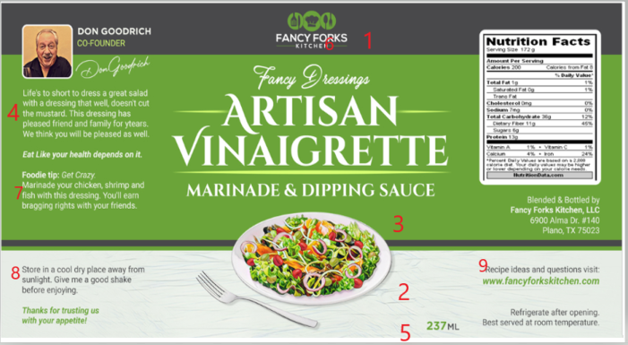
My comments made on Thursday 6 Feb
- Our Fancy Forks logo needs to be bigger. Maybe 25%
- Move the salad plate down. This will give more room to satisfy item no. 1. The fork will need to be adjusted and move it to the right side of the plate.
- Delete DIPPING SAUCE and just say “AND MARINADE”
- Reword this paragraph to say: Life's too short to dress a great salad with a dressing that doesn't cut the mustard. This dressing has been a favorite of friends and family for years. We hope it becomes yours.
- Should say NET 8 FL OZ (237 ML )
- Add a Trademark Symbol ™ at these locations
- Reword to say:
Foodie Tip
Get Crazy. Marinade
your chicken and seafood with this dressing
and earn bragging rights.

8 Reword this paragraph
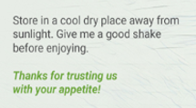
To this:

Give me a good shake before enjoying.
Made in Small Batches because we can.

Thanks for trusting us with your appetite!
savour the experience… ™

9 For recipe ideas and questions visit:
www.fancyforkskitchen.com

