
Farmer Experience
https://www.flaticon.com/free-icon/user-experience_2274940?term=user%20experience&page=1&position=4

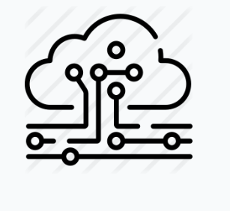
Digitally Powered
https://www.flaticon.com/free-icon/cloud_1793151?term=distribution&page=1&position=5
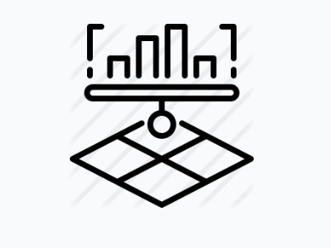
Product Performance
https://www.flaticon.com/premium-icon/plantation_2331296

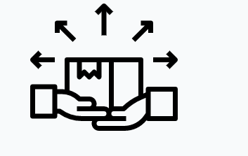
Go to Market
https://www.flaticon.com/free-icon/distributed_2145525?term=distribution&page=1&position=49

