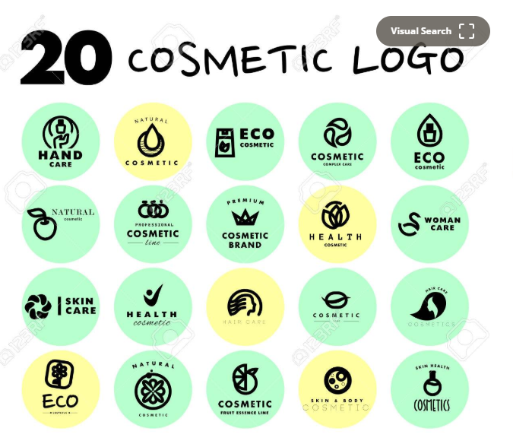
https://www.123rf.com/photo_52806931_vector-simple-flat-cosmetic-logo-template-collection-minimalistic-icon-and-logo-design-beauty-indust.html

