Humuhumunukunukuapua'a Fish Package Design

Key facts

- We are charging a premium price and the design must reflect it’s a premium product.
- The package size will change, and the design must be flexible enough to fit on a smaller or larger package.
- Original package size will be 4.82” x 6.24” (that’s in inches)
- We can do gloss or matte gloss finishes
- The bag seal at the top and include a hole punch for the product to hang.
- We will provide the following to include in the design
  - Barcode (for the back of the package)
  - Nutrition Information (for the back of the package)
  - Photo of the Humuhumunukunukuapua'a (for the back of the package)
- The final delivery must include the following
  - Your take on the fish saved as a separate file
  - Front of the bag
  - Back of the bag

4.82" x

Front Must have the following. Feel free to add what your design calls for to complete it but the following must be included on the front of the package

- Your take on the humuhumunukunukuapua'a (we have included a couple of examples, but we are looking for your take as part of the design)
- The slogan (see below)
- The flavors – Pineapple is the key flavor and must be listed first
- The weight at the bottom of the package

Humuhumunukunukuapua'a Fish
Premium humuhumunukunukuapua'a Fish a Hawaiian Treat

Below are a couple of examples of the Humuhumunukunukuapua'a (not for use, just examples)

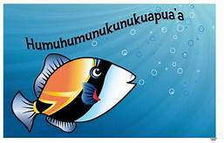

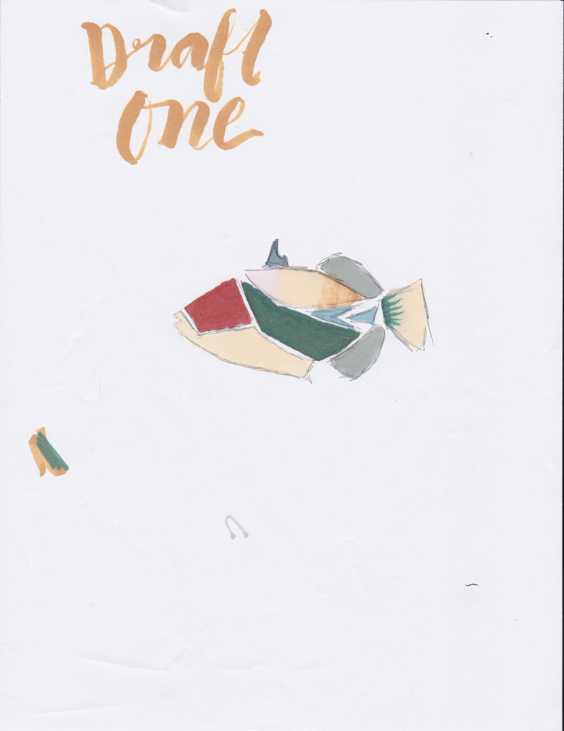

Pineapple, Citrus and Raspberry
Net Weight 5.0 oz

Back

(Facts that can be used on the back – does not have to be a check box)
 | Humuhumunukunukuapua'a Fish | Swedish Fish
Free of Corn Syrup |  | 
Natural Colors
Non GMO
Pineapple

Humuhumunukunukuapua'a
Here’s how to pronounce it: “who-moo-who-moo-noo-koo-noo-koo-ah-pooah-ah”

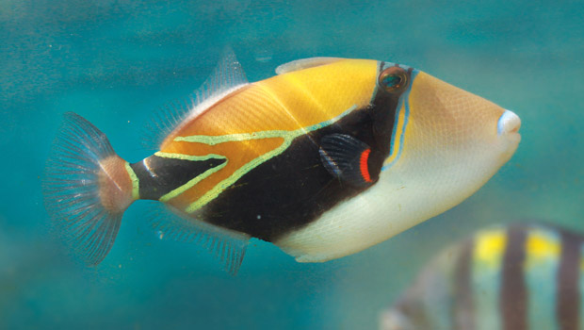

Humuhumunukunukuapua'a Fish is the state fish of Hawaii. The humuhumunukunukuapua’a is a tropical reef trigger fish that you’ll likely see when you snorkel in Hawaii.

Barcode

Nutrition Facts

Sugar, invert sugar syrup, corn starch, glucose syrup, acidity regulator (citric acid), aroma, glazing agent (carnauba vax, coconut oil). Colors: Turmeric, carmin.

