PROFILE

Alrouf lighting technology Co. Ltd is part of Alrouf group consisting of Alrouf construction and Alrouf factory started back in 1995.
Alrouf constructions is specializes in industrial construction activities including civil, mechanical and electrical works.
Alrouf factory is an electrical accessories manufacturers located in second industrial area in Dammam that manufactures electrical metallic pipes and switch boxes.
Alrouf Electrical Accessories Manufacturer started business early in 2003, and has taken care to its customers and maintenance quality ever since. To this end the company employs a highly efficient team with long experience in a variety of specialization. We are confident of executing our work to the highest standards and quality. The company leads in the field of electrical accessories

HIGHBAY
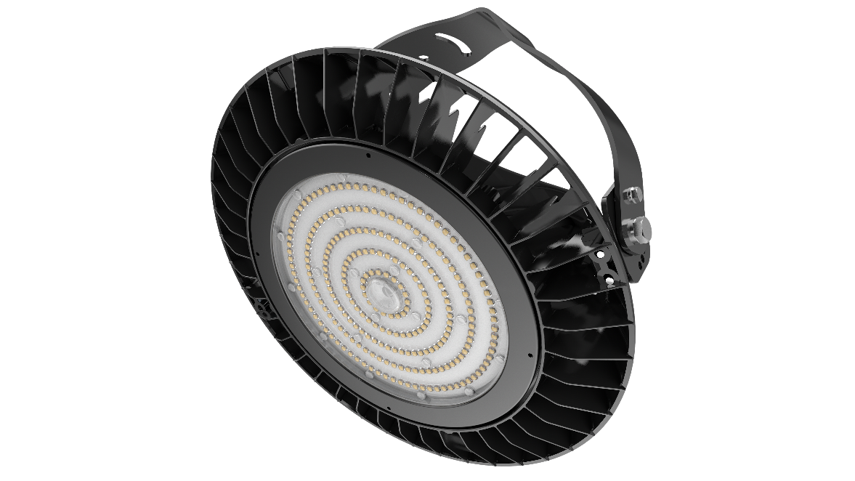

Highbay Series are designed for industrial lighting adopting the newest LED lighting technology with higher lm/w light efficiency.

AREA OF APPLICATION
Factories, Warehouse, High room, Exhibition Hall.

Watts | 150 | 200 | 230
Input Voltage | 220-240/ 110-220 Vac
Frequency Range | 50Hz-60Hz
Total Harmonic Distortion | ≤9%
Power Factor | >0.95
Power Efficiency | >91%
LED CHIP | NICHIA
LED Luminous Efficiency | 110-120Lm/W
LED Total Flux | 16000-18000 | 22000-24000 | 25000-27600
Lamp's Efficiency | 100%
Available beam angles | 60°/90°/110°
Illuminance Uniformity | >0.7
Color Temperature | 2700-6500K
Color Rendering Index | Ra>80
Light Distribution | Symmetrical
Working Temperature | -30℃～+55℃
IP Grade | IP65
Working Life-span | >50000H
Certificate | CB, EER, IECEE,SABER

FLOOD LIGHT
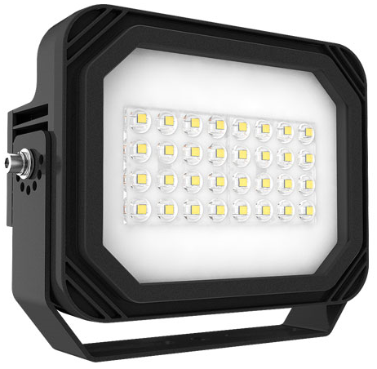

An Industrial grade Flood Light has an innovation design and different optics for the best performance in the lighting distribution.

AREA OF APPLICATION
Freight yards, Board illumination, Ports and airports, Landscape lighting

Watts | 100 | 150 | 200 | 230
Input Voltage | 220-240 / 110-220 Vac
Frequency Range | 50Hz-60Hz
Total Harmonic Distortion | ≤9%
Power Factor | >0.95
Power Efficiency | >91%
LED CHIP | NICHIA
LED Luminous Efficiency | 110-120Lm/W
LED Total Flux | 11000-12000 | 16000-18000 | 22000-24000 | 25000-27600
Lamp's Efficiency | 100%
Illuminance Uniformity | >0.7
Color Temperature | 2700-6500K
Color Rendering Index | Ra>80
Light Distribution | Symmetrical
Working Temperature | -30℃～+55℃
IP Grade | IP65
Working Life-span | >50000H
Certificate | CB, EER, IECEE,SABER

STREET LIGHT

This robust and high-performance LED Streetlight brings a uniform lighting experience to large spaces brings comfort and safety to road or street.

Tool free maintenance design with strong Anti-corrosion grade materials and higher heat dissipation cover

OPTIONAL
Wide range of optic lenses, Beam and Colour

AREA OF APPLICATION

Road & Streets, Parking lots

Watts | 100 | 150 | 200 | 230
Input Voltage | 220-240/85-265 Vac
Frequency Range | 50Hz-60Hz
Total Harmonic Distortion | ≤9%
Power Factor | >0.95
Power Efficiency | >91%
LED CHIP | NICHIA/PHILIPS/CREE
LED Luminous Efficiency | 110-120Lm/W
LED Total Flux |  | 16000-18000 | 22000-24000 | 25000-27600
Lamp's Efficiency | 100%
Illuminance Uniformity | >0.7
Color Temperature | 2700-6500K
Color Rendering Index | Ra>80
Light Distribution | Symmetrical
Working Temperature | -30℃～+55℃
IP Grade | IP65
Working Life-span | >50000H
Certificate | CB, EER, IECEE,SABER

CANOPY LIGHT

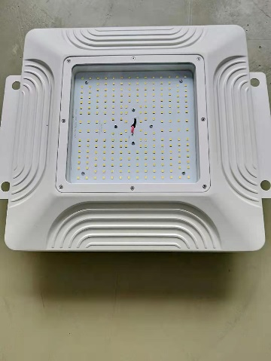

Watts | 100
Input Voltage | 100-277Vac
Frequency Range | 50Hz-60Hz
Total Harmonic Distortion | ≤9%
Power Factor | >0.95
Power Efficiency | >91%
LED CHIP | NICHIA
LED Luminous Efficiency | 150Lm/W
LED Total Flux | 15000 lumen
Lamp's Efficiency | 100%
Illuminance Uniformity | >0.7
Color Temperature | 2700-6500K
Color Rendering Index | Ra>80
Light Distribution | Symmetrical
Working Temperature | -30℃～+55℃
IP Grade | IP66
Working Life-span | >50000H
Certificate | CB, EER, IECEE,SABER

TRI PROOF
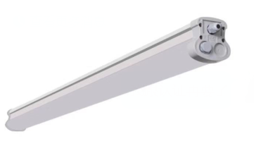

Highly durable and robust Tri-Proof light designed for harsh conditions have to be countered.

AREA OF APPLICATION
Parking Facilities, corridors and hallways; Warehouses and storage rooms; Factories and production areas

Watts | 30 | 40 | 60 | 110
Input Voltage | 220-240/100-277Vac
Frequency Range | 50Hz-60Hz
Total Harmonic Distortion | ≤9%
Power Factor | >0.95
Power Efficiency | >91%
LED Luminous Efficiency | 130Lm/W
LED Total Flux | 3900 | 5200 | 7200 | 14300
Lamp's Efficiency | 100%
Safety features | Open circuit protection, short circuit protection, overvoltage protection
Color Temperature | 2700-6500K
Color Rendering Index | Ra>80
Beam Angle | 120°
Working Temperature | -30℃～+50℃
IP Grade | IP65
Working Life-span | >50000H
Certificate | CB, EER, IECEE,SABER

PANEL LIGHT

Shallow, Edge lit panel for lay-in, concealed and plasterboard ceilings as well as for surface mounting or wire suspension

AREA OF APPLICATION
OFFICE LIGHTING,

Watts | 40
Input Voltage | 100-277 Vac
Frequency Range | 50Hz-60Hz
Total Harmonic Distortion | ≤9%
Power Factor | >0.95
Power Efficiency | >91%
LED Luminous Efficiency | 110-120Lm/W
LED Total Flux | 4000 lumen
Lamp's Efficiency | 100%
Illuminance Uniformity | >0.7
Color Temperature | 2700-6500K
Color Rendering Index | Ra>80
Light Distribution | Symmetrical
IP Grade | IP40
Working Life-span | >50000H
Certificate | CB, EER, IECEE,SABER

EMERGENCY LIGHT

Product Specification: Weatherproof 2 X 3W white LED non-maintained twin-spot emergency luminaire complete with high temperature NiCD batteries for 8 hours DC duration.

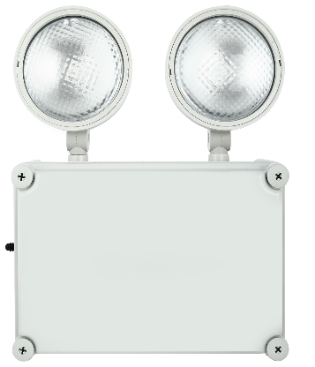 | Mode of Emergency
 | Non-Maintained Mode
 | Lamp Source
 | 2 X 3W White LED
 | Housing Construction
 | Fire Retardant (UL94V0) Housing with snap-in design & UV Stabilized Twin Diffuser
 | Emergency DC duration
 | 3 hours & 8 Hours
 | Battery used
 | High temperature NiCD Batteries
 | Mounting
 | Wall/ Surface Ceiling/Suspend

Areas of application
Safety signs, Buildings requiring up to 3 h or 8 h emergency light operation
EXIT LIGHT

Compact and modern design with extruded Aluminum housing Safety signs with various mounting options for wall, ceiling, recessed and pendant
Operation mode: maintained (M) or non-maintained (NM)
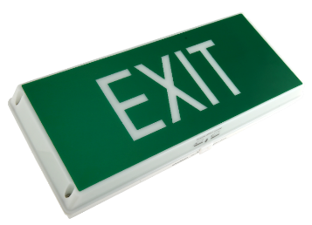 | Mode of Operation
 | Maintained
 | Power Consumption
 | 3W
 | Emergency DC duration
 | 3 hours & 8 Hours
 | Protection Classification
 | IP 65
 | Housing Construction
 | Injection molded fire retardant high impact

Areas of application
Safety signs, Buildings requiring up to 3 h or 8 h emergency light operation

EXPLOSION PROOF

Traditional lighting technologies such as Metal Halide, Fluorescent and High Pressure Sodium, require significant and frequent maintenance. Work sites and plants must stock many different types of lamps, ballasts and other fixture components to maintain these systems. These older technologies have short lifespans, poor lumen maintenance and contain material harmful to our environment. When designed properly, LED systems can offer superior energy efficiency, reliability, longevity, improved light levels, visual clarity, and ultimately cost savings from reduced or eliminated lighting related maintenance, certified lamp recycling and of course energy costs.
Especially harsh industrial environments requiring advanced lighting that is efficient, supports productivity, and above all, ensures the safety of their employees.

BRANDS
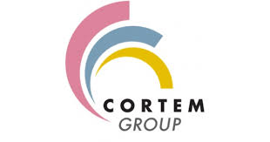

CASE STUDY

SIPCHEM reformer area combination of highbay and area light is not only inefficient and unacceptable for the continuous emitting higher degree temperature, but they also make it difficult for staff to perform their work without the use of supplemental, temporary, portable lights. In addition, ongoing maintenance is a challenge. Workers must build scaffolding and timely changing lamps and accessories with portable lighting. Heat emission from equipment causing fixtures frequent failures, so maintenance is an on-going process.
Our Designers working for a better solution, aiming to light the facility with the latest-generation LED fixtures to provide the most energy-efficient, safe and reliable illumination.
Therefore we proposed a new design with DIALIGHT FLOOD LIGHT to illuminate a light between aisle along with area light for passage. The goals for these to reduce total energy consumption, maximize lighting efficiency, improve sustainability and safety, and reduce maintenance demand and lower total operating cost.

VENDOR CODE:

ARAMCO 0010056392
SAUDI ELECTRICITY 2006100
SIPCHEM 103375.
MARAFIQ 2000012009
MAADEEN 39380
SABIC 508386

BRANCH:
DAMMAM, JEDDAH

CLIENTS:
Sipchem, swcc , panda, arabian pipes,

