ANFIELD GIN LABEL

We Wish the label to look like this in almost every way however The Blue needs to be Red in colour.
Keeping the gold. The signature will need to be changed however I can provide this.
The gold ‘Stamp Mark’ need to be replaced with our new logo…
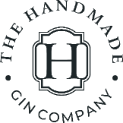
Same applies to the neck label
