Brand: Florozone | Date:15/01/2020

- What is the task at hand and resulting marketing objective?

Task at hand:

Design new artwork of packaging for Florozone Anti-Ageing cream
The product will be packed in a glass jar.

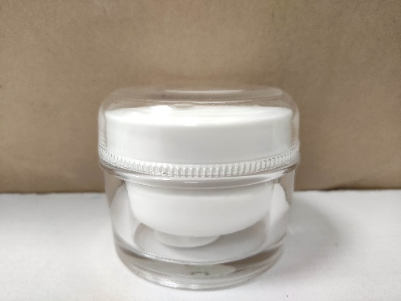

Marketing objective:
To create an attractive packaging for the new product that highlights the USP of the product.
It will sell in retail shop and Ecommerce portals
USP

- Helps repair , Firm up & Rejuvenate the skin : Powered by Ascorbyl glucoside
- Tightens the skin and stimulates collagen synthesis.
- Aids in the removal of wrinkles
- Reduce marks & fine lines.
- With fruit extract to maintain the natural glow of skin

Ensure that the packaging needs to stand out of the clutter of Anti-Ageing packs in the market. Design to highlight the Fruit extract that will make it stand out in the clutter.

About the product:

It is an Anti-Ageing cream for all skin types, It tightens skin & stimulates collagen synthesis. Product has following properties

  - With Anti-Oxidants to fight free radicals
  - Evens skin tone
  - Moisturize
  - Replenishes moisture and keeps your skin hydrated.
  - Brightens your skin for a healthy glow.
  - Mild Fragrance ( Feminine)
  - No Parabens & Mineral oils

- What is the role of communication & thus the measurable communication objective for this task

The role of the artwork is to highlight the USPs of the product.

MCO:
Consumer must believe that Florozone anti-ageing cream with natural ingredients help them to delay onset of ageing

- What insight drives this brief?

Skin care segment has become an important part of wellness and personal care. As skin is subjected to external conditions like exposure to UV radiation, pollution, changing temperature, etc.
Anti-aging products stand first in line among the age groups 25 - 55.With the rise customer’s interest in preventing the signs of aging, the anti-aging products market has gained huge popularity.
Florozone is known for its range of body lotions

Florozone Anti-ageing cream has special ingredients which tightens skin & stimulates collagen synthesis

Consumer profile:

- Who is our target audience?

TG: 30-45 years, SEC A men & women

- Proposition:

Florozone Anti-ageing cream to tightens skin& stimulate collagen synthesis

- Main point:
Enriched with Aloe-Vera & mixed fruit extract
Tightens the skin & stimulates the collagen synthesis
Depict Allantoin in circle , it should look more clinical or trustworthy

- Mandatories:
  - Good colour combination
  - Highlight ingredients
  - Highlight tightens skin & stimulates collagen synthesis
  - Please highlight if any printing related requirements like foiling, embossing , SPOT UV/Matt look etc..

Design texts:

A unique formulation, which nourishes dry & tired skin. It helps in faster cellular regeneration and maintains a youthful skin for a longer period .Aloe vera juice & mixed fruit extract nourishes the skin giving a youthful & healthy look.

Direction for use: Wash your face & pat dry . Apply “Florozone anti-ageing cream”. Apply on face & neck with gentle massaging
Brand Logo

Anti-Ageing cream

All skin types
Tightens skin & stimulates collagen synthesis
Allantoin

With Aloe juice & Mixed fruit extract
50 g

Side panel 1
Front panel

Ingredients : Aqua, Isopropyl myristate, Dimethicone,
Mfg by
Hygienic Research Institute Pvt Ltd
A/48, MIDC, Andheri east
Mumbai-400093 ; M.L.No: C/1128
For queries/Feedback
Customer care Executive
Hygienic Research Institute Pvt Ltd
Rgd.office: 602, Supreme chambers, Andheri (W) , Mumbai-400053. India
Toll Free no: 1800268110
Email : info@hriindia.com
Product : Skin cream
Net content/Net quantity : 50g
Batch No:
Mfgd
Use Before
MRP
Cetyl alcohol, Glycerine & Empetrum nigrum, Mixed
Fruit extract , Glyceryl monostearate, trehalose,
Biosaccharide Gum-4, Triethanolamine, carbomer,
Butyl hydroxytoluene, Phenoxyethanol, carbomer,
Butyl hydroxytoluene, Phenoxyethanol, Methylparaben,
Propylparaben methylisothiazolinone, Disodium EDTA,

For External use only

Back side
Side panel 2

Competition packs in the market:

Wow Anti-Ageing cream

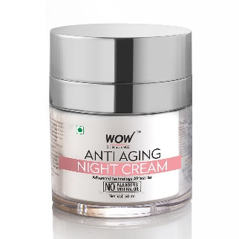

Neutrogena Anti-Ageing cream

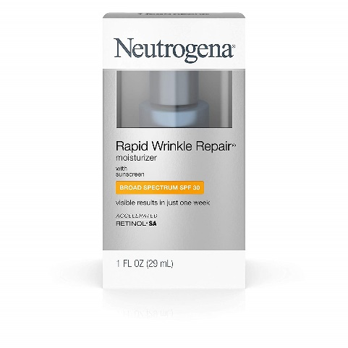

Goodcare Anti-Ageing cream

