Current Logo (dates back to 1988)

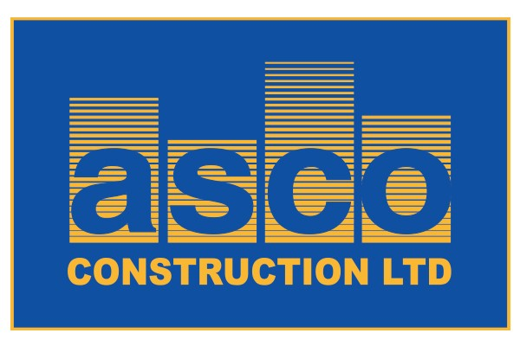

New Logo Project

After 30+ years with the same logo, we are looking to refresh and rebrand our company image. While we like the blue and yellow currently used in the logo, we are not attached to the depth or shade of the colours. We like the current font, but are open to similar simple styles. Our goal is to create a logo that is reflective of our commitment to employee empowerment, environmental consciousness, and cutting-edge technology that inspires and demonstrates our passion for quality construction. ASCO/asco must be used in the logo.

The word “Construction Ltd” does not have to be in the logo.

Must have an icon that is representative of our company which can be used on different media as a standalone branding symbol. We have different division / subsidiary as part of our group of companies and all use the word ASCO as the base. Example: ASCO Construction Ltd, ASCO Restoration Services, ASCO Real Estate & Development, ASCO Group of Companies.
Please do not hesitate to email me if you have any additional questions aassaly@ascoconstruction.com

Our website address is www.ascoconstruction.com the website was hacked recently and the look is odd and is being restored by Jan 15th.

Background information on the Company

Company began its operation in 1988 as a small family owned general contractor in Eastern Ontario, Canada. Since then, we have grown and open offices in Ottawa and Toronto and we serve both the Ontario and Quebec markets.

We operate as construction managers, design builders and general contractors, safely delivering cost effective construction solutions and services to our clients in the fields of institutional, commercial, industrial and civil work construction. The range of our project is from $1MM to $40MM and growing.

We do new construction, addition, upgrades and renovations in the following construction sectors:

- Commercial: Shopping centres, banks, restaurants
- Institutional: Healthcare such as hospitals, nursing and retirement homes
- Industrial: Heavy steel industry, light industrial warehouse, aggregate quarry
- Civil works: Water treatment plants, Sewage treatment plants, Pumping stations…

ASCO has built a solid foundation of trust and commitment with its employees, suppliers and subcontractors. Our comprehensive and teamwork approach to our projects in both the public and private sectors benefits all participants and mainly our clients.

At ASCO, we care. Our construction management team is devoted and dedicated to fully identify and comprehend the scope of our client’s requirements and to provide realistic cost effective solutions to achieve maximum satisfaction. We continuously improve our people and systems to anticipate our customers ever changing needs. Our priority is to deliver safe construction projects while creating value for our customers and maintaining long term business relationships with all our partners.

Mission Statement

ASCO Construction is committed to becoming the preferred single source construction solution and services provider in Eastern Canada. By staying focused on providing consistently outstanding service and value, we will warrant repeat and referral business which will fuel the long term growth of our people, our partners and our organization.

Our slogan
Construction Solutions - Lasting Relations

Our Corporate Values
Pride – we take pride in our accomplishments
Initiative – we value and recognize the initiative taken by employees and subcontractors to improve our organization and its processes
Passion – Our people are passionate about construction and providing cost effective solutions
Caring – of our employees, subcontractors and client’s needs
Excellence – doing the job right the first time.
Trust - ASCO trusts its employees and its employees trust ASCO Construction
Integrity – Everything we do is above board, honest and transparent
Environmentally sensitive - our project are executed with utmost respect and protection to our environment

Our Commitment to Clients

Peace of mind & convenience - Our commitment to your project will offer you piece of mind. We will strive to minimize disruption in your normal business operations and/or activities and make the ASCO experience as convenient as possible.
Reliability and dependability – You will have access to decisional competent staff that will make sure that all your needs are met and questions/concerns answered promptly and efficiently and that agreed upon schedules are respected.
Safety – Health & safety is an integral part of our culture and every project we undertake.
Value – We always give our 100% to each of our clients so they obtain their money’s worth: quality construction, respect of budgetary constraints and agreed upon timelines.
Integrity & honesty – We will maintain open and honest communications with you to allow you to understand the progress and constraints of your project.

