Extra information
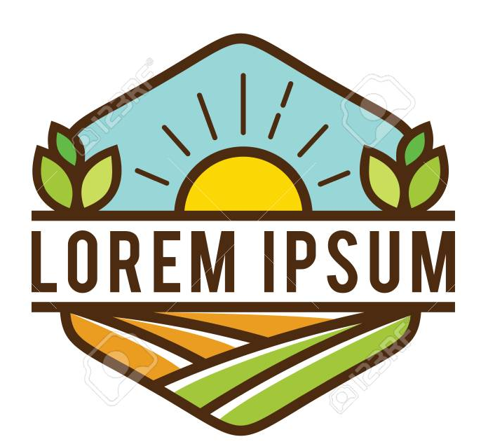
What we like about this logo: the set-up, the bright colours, happy feeling and the lining (thick and clear).

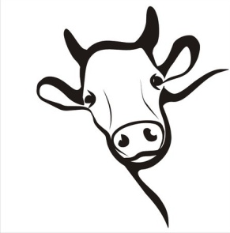
We like to have a cow head (something like this, but without the horns) as the center, or the eye catcher of the logo. For your information, a modern cow doesn’t have horns. We like the cow to look happy (but not like in a childs book).
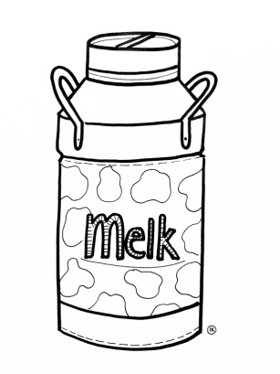
We also would like a visual of a milk can in the logo, not too big, but to show our main purpose is making milk.
Extra information
- We would also like to see a meat icon on the visual, a steak or something. A part of our business is selling meat, but only if this fits in the logo, it should be added.

