Brand: Florozone | Date:05/12/2019

- What is the task at hand and resulting marketing objective?

Task at hand:

Design new artwork of packaging for Florozone Anti-pollution Sunscreen SPF 50
The product will be packed in a lami tube.

Marketing objective:
To create an attractive packaging for the new product that highlights the USP of the product.
It will sell in retail shop and Ecommerce portals
USP

- Protect against pollutant particles up to 2.5 microns
- Water resistant sunscreen.
- Provides protection from UVA & UVB rays.
- Contains Aloe Vera to provide soothing effect on skin.
- Suitable for all skin types

Ensure that the packaging needs to stand out of the clutter of sunscreen packs in the market. Design to highlight the Aloevera that will make it stand out in the clutter.

About the product:

It is an Anti-pollution sunscreen with SPF 50 which shields skin from pollutant particles up to 2.5 microns. Product is enriched with Aloe Vera to provide soothing effect. It is water resistant sunscreen with following properties

  - Good spread ability
  - Non Greasy & non oily
  - Non irritating
  - No Parabens & No mineral oil

- What is the role of communication & thus the measurable communication objective for this task

The role of the artwork is to highlight the USPs of the product.

MCO:
Consumer must believe in the sun + pollution protection message that is to be delivered through its packaging.

- What insight drives this brief?

For consumer, protection from pollution means protection from UV rays & dirt. In addition to UV rays, pollutants found in the air can also negatively impact skin, these can lead to inflammation, which in turn can lead to hyperpigmentation and collagen breakdown causing increased wrinkle formation.

The new generation consumers are very selective when it comes to the selection of skin care products. They carefully select the product as per their skin type. Antipollution sunscreen will give them an upper hand compared to conventional sunscreens available in the market

Florozone is known for its range of body lotions

Florozone Anti-pollution sunscreen has special ingredients which protect the skin against the pollutant particles along with protection against UVA & UVB rays

Consumer profile:

- Who is our target audience?

TG: 30-45 years, SEC A men & women

- Proposition:

Florozone Antipollution Sunscreen with SPF 50 : Sun + pollution protection

- Main point:
Enriched with Aloe-Vera
Protection against pollutant particles up to 2.5 microns

- Mandatories:
  - Mixture of yellow colour
  - Highlight ingredients
  - Highlight SPF 50
  - Highlight Aloe vera on the pack

Competition packs in the market:

Wow Antipollution Sunscreen SPF 40 @ Rs 399

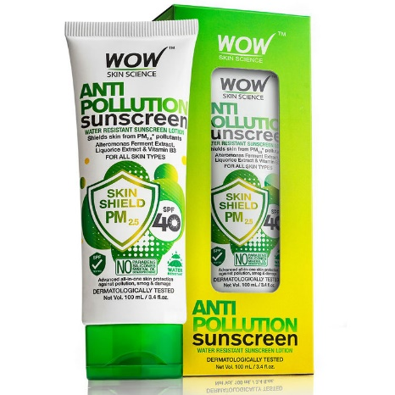

Neutrogena Ultra sheer sunscreen SPF 50 @ Rs 549

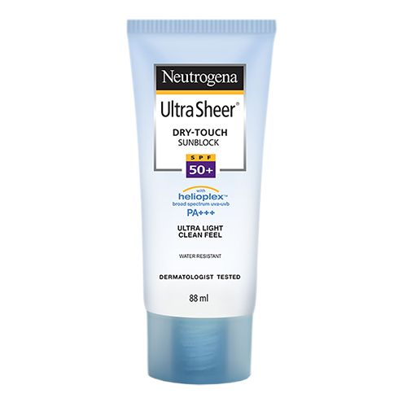

Lakme sun exper @ Rs 250

