We are going to recognise the people who work towards the global goals in order to make the work a better place
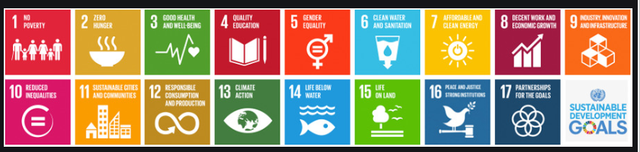

  I can see these 2 logo’s combined. The angel in the centre of a globe with the whale tail at the bottom coming into the global

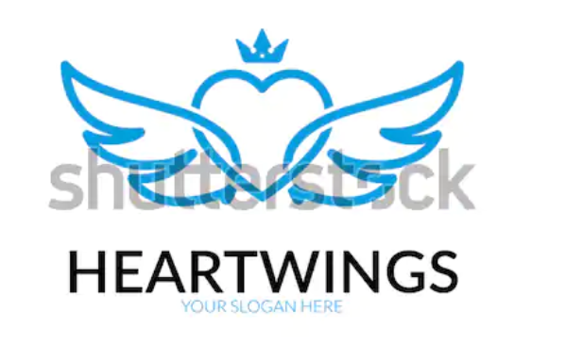  or something like with of these at the bottom of a globe with the people joined together around the rest of the globe.

This is good cause it represents global peace. If we can bring in world unity to it also?


I like this for the strength it shows

