SUMMARY

We will need three mockups that are as follows:

- A mockup of a homepage that will be on www.latutors123.com
- A mockup of a free-standing true landing page that will be a one-page site where we will direct traffic from a Google PPC ad.
- A mockup of a landing page that will replace a landing page such as the one at www.latutors123.com/test-prep-services/k-12/sat/

The details for each of the three items will be found separately below.

COLOR SCHEME

The current color scheme for the website is a combination of a white background, grey text, and the colors you see on the main page referenced above. The colors are:

Gray Text - #676767
Light Blue - #2dcaf1
Slightly Darker Blue - #2e93a7
Orange - #ee7b55
Yellow/Gold - #f5cf2e

We’d like to stick with that. Any colors used should be more on the lighter side. We’d like to avoid darker colors/themes.

FONTS

We currently use the following fonts:

Header Font – Josefin Sans
Main Text Font – Noto Sans
Main Menu Font – Kanit

We are open to fonts if they are Google fonts only. We don’t want to use fonts that a user must download in order to render the site text.

DEVELOPMENT NOTES

We have a developer who will take that homepage and main landing page mockup and code them into our existing WordPress website. The PPC page will be coded separately via standard HTML/CSS. All pages will need to be designed knowing that they will be coded in a responsive manner to have the page display properly for mobile, tablet, and desktop devices.
HOMEPAGE DESIGN

We are looking for a homepage design that ties in with the newly redesigned landing pages described below. For reference, here is our current website homepage which was just redesigned within the last few weeks:
https://www.latutors123.com/

The previous homepage can be found here:
https://www.latutors123.com/old2019/

Additionally, we had someone working on this for us before we settled on the current homepage. This page just lacked any design elements that we feel are necessary to make our page stand out:
https://demo.latutors123.com/

Here are some of the websites of our competitors whose style and flow we like:
https://www.varsitytutors.com/los_angeles-isee-tutoring
https://magoosh.com/
https://blueprintlsat.com/

And here are the sections needed:

- Section 1 - We like the top banner and would not need any changes to it (we're open to suggestions though)
- Section 2 - We need a section for services like the current homepage (Academic Support, K-12 Test Prep, etc.) that is easy to read and stands out.
- Section 3 - We'll have a "Results" section next. Please see the demo site for the section with circles. We're looking for something like https://www.studypoint.com/ where they show SAT, ACT, etc. results. Please also see https://www.princetonreview.com/ for SAT, ACT, MCAT results section.
- Section 4 - We want to add a section similar to "Systematically Improving Scores One Student at a Time" on https://www.studypoint.com/ and call it "How it Works"
- Section 5 - We'll have a section with a few of our tutor bios.
- Section 6 - We'll have our contact number and a contact form for the last section.

The current website can be used for text that can be placed on the mockup you provide.

PPC LANDING PAGE

This page will be a one-page landing page completely independent of the main website. It will not need the top menu or footer that exists currently. We do want it to tie into the site in both color scheme, fonts, etc. Here is an example of a landing page design we like:

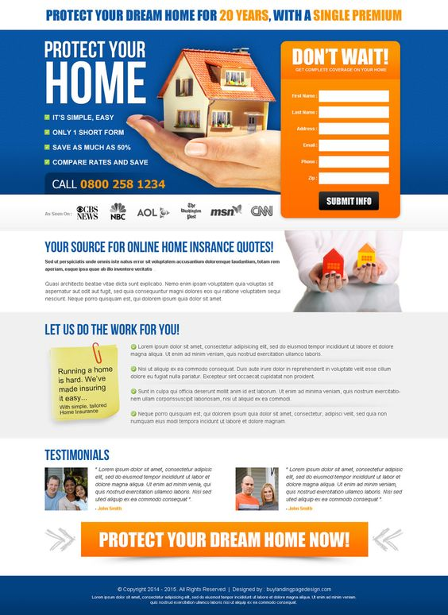
There should be a header with a phone number and four main sections. The object of the page will be to get people to call or to submit information on a web form.

HEADER - Call for your Free ISEE Consultation – (833) 333-7737

SECTION 1 – Should have an image background behind the content. Look to our website for inspiration on images. The content will contain the words and form below:

Award-Winning ISEE Test  Prep Tutors in Beverly Hills  Learn from the best professional ISEE  instructors in Beverly Hills! Backed by  Our Score Improvement Guarantee  And 100% Tutor Satisfaction Guarantee. | Schedule a Free  Consultation!  [ Full Name (required)]  [Email (required)]  [Phone (required)]  [Tutoring Subject (required)]  [Home Zip Code (required)]

Underneath this section we’d like an As Seen On bar like the design above and to what we have on the current website at latutors123.com.

SECTION 2 – A separate section from the above with the text below. The items can be listed like this or in columns. We would like some icons or imagery within to break up the text.

Why choose LA Tutors 123?

Connect with an expert educator who can help your child learn the best test taking strategies and find the confidence to master the ISEE. Study smarter, not harder.

CUSTOMIZED GAME PLAN (ICON)

Complete our free diagnostic test to gauge your strengths and weaknesses, and we’ll create an adaptable learning plan just for you. Simple. And somewhat magical.

HAND-PICKED, PROFESSIONAL TUTORS (ICON)

Because every student is unique, we hand pick our ISEE experts based on teaching style, personality, location, and availability.

GUARANTEED RESULTS (ICON)

Enjoy peace of mind knowing we stand behind our service. We guarantee you and your student will be 100% satisfied with your experience.

ICON OR IMAGE

2 stanine point improvement
100+ students accepted to top school choice

Section 3 – A section below the one above that stands out whether with a color or imagery, etc. In this section we’ll have a header sentence and then icons for several schools that are located at the bottom of our previous homepage design located at https://www.latutors123.com/old2019/.

Our Students Excel at These Fine Schools

Logos to be provided

Section 4 – A section below the one above that will highlight the tutors we have for this test. The header text, regular text, and tutors are below. For this, we want to see the images smaller and in a circle.

Top Experts Delivering Top Scores

How do we know you’ll get a great tutor or instructor? Well, we only choose to work with the absolute best, which starts with an intensive vetting process (interviews, background checks, simulated tutoring sessions). Then we hand pick the right one based on location, specific needs and personality.

  Jeremy  Harvard University  20 Years of Tutoring |   Theo  Princeton University  11 Years of Tutoring | 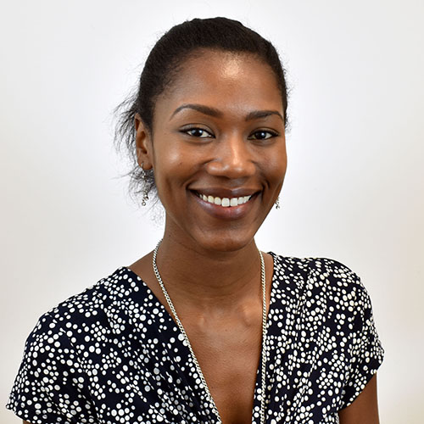  Dara  Brown University  5 Years of Tutoring
Footer section – This will be a short sentence along with a button that will take someone to the contact page at www.latutors123.com/contact-us/

Call us today to get started with a veteran
Beverly Hills ISEE tutor! (833) 333-7737

Button Labeled SCHEDULE A CONSULTATION

WEBSITE LANDING PAGE

This page will be a landing page that will need to fit within the design of the main website. It will require the top menu and footer that exists currently. The font and color scheme will tie in with the existing design: www.latutors123.com/test-prep-services/k-12/sat/ and with the design of the homepage from mockup #1.

But it can take many of the elements of the PPC landing page including the prominence of the contact form and the contact form at the bottom. The phone number should be displayed prominently as well within the body of the landing page.

The sections will match those in the PPC Landing Page.

