
I love the spacing and format.


This one does a great job of balance and incorporating the artwork into the actual lettering.


This is worth noting for its simplicity. But there’s nothing that speaks of the churches culture or values.


This logo is very nice, clean, sophisticated.


One of the largest churches in the country. The placement of the lettering and format/spacing of Lakewood to Church is good.
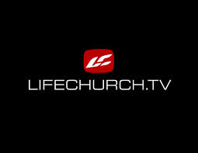
Another church that is massive. Very different feel, but the style is widely popular in church world.

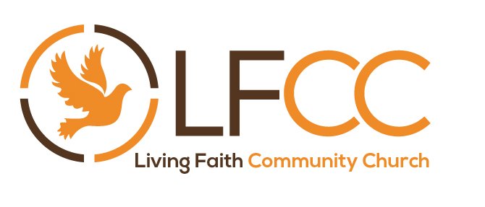
Here’s a church that did something cool with the 4 word name of the church. One of the few that I’ve seen available. Doesn’t grab my attention, and there is a lot going on, but worth noting.

Got through the first 960 logos on BrandCrowd and nothing. First 7 pages of Fivrr and found 1 that looked appealing:

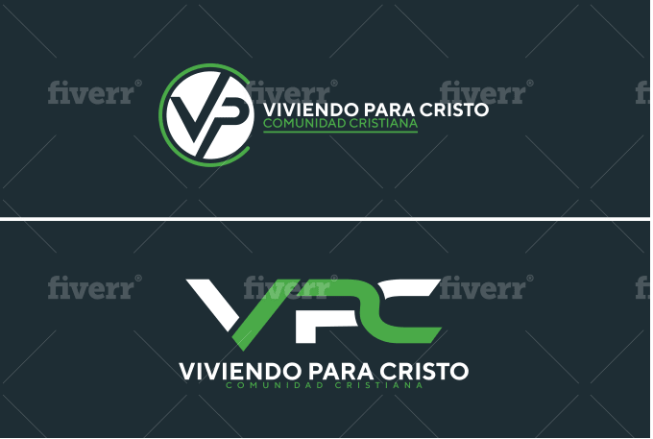
This is probably the best example of style and format that I’m looking for, but still very far from what I’m exactly looking for.

I need an artist that can take everything I’ve mentioned, comb through it, and see what works. Something that covers all the parameters and needs which should limit it down quite a bit.

