About Us:

Petro is a premier provider of full service civil, structural, mechanical, fabrication, electrical and instrumentation construction and maintenance services. Petro has a long successful history of managing and meeting the challenging schedules and budgets of projects of all sizes, and we are consistently recognized for our exemplary safety record and work quality. Our experience, breadth of projects, dedication to safety and excellent corporate culture help us attract and retain the most highly skilled team of craft and supervisors available to serve our clients’ needs.
Petro boasts a workforce of specialized professionals available to meet the needs of today's petro-chemical industry in the United States and across the Caribbean.​ Our craftsmen have a strong reputation for providing quality service using the most innovative and technologically advanced equipment available today. With offices located in Texas and St. Croix, USVI, we are confident we can provide services and on-site consultation on a timely basis.
“Petro is a company built on the accomplishments of its talented and skilled employees.” – Adrian Melendez, President

Our Mission:

Our mission is to provide a rapidly modernizing industry with highly trained professionals and quality production through continuous training and up to date company standards.
From its inception in 2016, Petro Industrial was designed to provide above industry standard pay and benefit packages with the intent of attracting and retaining the highest quality craftsmen.
Complimenting both established and new workforces in the oil and gas, power-generation, chemical and pharmaceutical industries, and distilleries, our dedicated labor force bring their experience and knowledge directly to your company.

Our Management team consists of professional groups with between 15 and 40+ years of experience in all aspects of the oil and gas industry.

Considered to be experts in their fields, they are available year round in on-site positions, guaranteeing the successful completion of each individual contract. In addition to managing their teams, each supervisor actively participates in the contract work ensuring all aspects of the job run smoothly.

SERVICES:
Focusing on labor specific skills allows Petro to develop teams of qualified craftsmen that are hard to find in today's international workforce.
​These specialized skills are needed by many companies for both long term and short term projects and for both fabrication and maintenance. Petro gives each client the opportunity to pinpoint individual skills and utilize our talented workforce accordingly.
Project Management:
Our project management personnel provide a full scope of services including:
- Project Analysis and Economic Appraisals
- Total Asset Management
- Production Operations and Maintenance Services
- Asset Integrity and Maintenance Engineering
- Intervention Engineering and Management
- CAD Design Services

PERSONNEL
Petro provides field supervision at all levels of production assistance.
- Compliance Technicians / Safety Representatives
- Customized Training
- Operator Development Program
- Total Asset Management
- Facility/ Safety / Regulatory Audits
- Drafting Services – Facility Drawings, Revisions, MMS Submittal
- Operating Procedures

Fabrication Services:
Petro Fabrication provides fabrication services to the global petrochemical, refinement, desalination, distilleries, and power generation industries. Incorporated in 2016 with modern and cost efficient principles, Petro provided the highest caliber craftsmen to worksites around the US and the Caribbean. Petro Fabrication sees to further consolidate and mitigate costs in an industry with ever growing inefficiencies.
Our team at Petro work with clients from cradle to grave, ensuring that all projects are completed and installed to the stringent and timely requirements of industry giants.

Fabrication
PIPE SYSTEMS
The core of our business is providing high quality, ready to install pipe spools in a variety of Carbon, Stainless and Specialty steel alloys, ready for easy and cost effective installation.
JACKETED PIPE SYSTEMS
The outer jacket may hold a heating or cooling fluid to control temperature of the inner process pipe; or serve as a safety barrier in containment piping.
INSTALLATION PACKAGES
Supports, Specialty Items,
Nuts, Bolts, Gaskets
A Complete Package of ready to install modular pipe spools and associated components.
PIPE SUPPORTS AND HANGERS
Sway Struts, U-Bolts,
and other hangers.
Structural Steel, Angle Iron,
W Beams, Tube Steel
BLAST AND PAINT
Offering a wide variety of coatings and surface preparation options such as ID/OD Sand Blasting, Painting, Specialty Coatings, Galvanizing, Pickle, Passivate, Oil and/or Fog.

Welding/Specialty Welding Processes
- Gas Metal Arc (MIG)
- Gas Tungsten Arc (TIG)
- Shielded Metal Arc (SMAW)
- Flux Core Arc Welding (FCAW)
- Wire Feed Orbital Welding

Instrument/Electrical Service:
Global industry is becoming more and more automated; reliant on complex instrumentation and electrical equipment. Petro has proactively pursued attracting and maintaining the industries more experienced I&E technicians in order to better serve our clients.

With over an average of 11 years of industry experience per employee, we are confident in our ability to meet project expectations and ensure a safe and productive experience.

Petro provides field supervision at all levels of production assistance.
- Meter Runs (manufacture, install, service and repair)
- LACT Units (manufacture, install, service and repair)
- AC Drives (service, install and repair)
- SCR’s (service, install and repair)
- Generators (service, install and repair)
- Fuel Loading Docks (manufacture, install, service and repair)
- Motor Control Centers (service, install and repair)
- Motor Starters (service, install and repair)
- 3-Phase Motors (service, install and repair)
- Motor Controls (service, install and repair)
- Plant Maintenance (service, install and repair)
- Process Plants (manufacture, install, service and repair)
- PLC and Flow Computer Programming
- Pneumatic Panels- Engineering and Fabrication
- Pneumatic Technicians
- Field Service Personnel for 24 hour Call-Out or Rotating Schedule (7 & 7, 14 & 14, etc.)
- Site Electrical and Pneumatic Troubleshooting and Installations
- Functional Testing of Safety Systems
- Electricians

Maintenance Services:
Petro was founded on the principles, values and successful performance of maintenance work. Industry infrastructure requires multiple considerations when planning and executing maintenance projects and we aim to assist at every junction.
Our maintenance personnel and craftsmen are highly trained and ready to work. Petro in house training in conjunction with industry certification courses are completed on a regular basis to provide the best service we can offer to our clients all around the globe.

Our personnel and mechanical service teams offer a full spectrum of services ranging from plant turnarounds to major overhauls for land, offshore, and pipeline facilities.
- Computer Based Maintenance Management System, including Supervision.
- Mechanical Personnel – Available for 24 hour call out or rotating schedules (7 & 7, 14 & 14, etc.)
- Overhaul crews Available for both High speed and Slow speed Compressors and Engines
- Repair, Maintenance, and overhauls of:
-Natural Gas Engines
-Diesel Engines
-Compressors
-Generator Packages
-Pumps
-Exchange Engines – Diesel and Gas
-Compressor and Engine parts sales

- Hydrostatic Testing
- Sandblasting
- Underground Coatings
- Anomaly Repairs
- Hydro-Excavation
  - Non-Destructive Excavation and Trenching
  - Line / utility Locating
  - Tank Cleaning

Tank & Vessel Services:
Our team at Petro offers teams with vast experience in designing, fabrication and erecting complex tank systems. The ability to provide inventive and cutting edge solutions contributes to better project performance and a longer return on investment. We always strive to deliver work that meets and exceeds your expectations in product containment, processing and storage.
Specialty Services
- Foundation Construction
- Tank Leak Detection and Containment Systems
- Tank Insulation Systems
- Vacuum Chamber Construction
- API Tank Inspection & Repairs/Alterations
- Sand Blaster & Coating
- Large Diameter Pipe Fabrication and Installation
- Fiberglass Tank Bottoms

Clients:
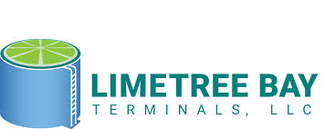

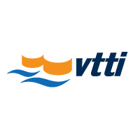

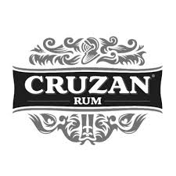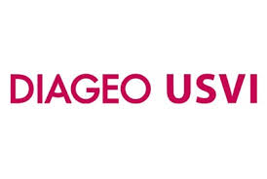
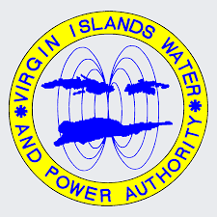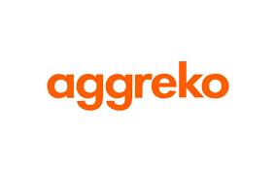
Blogs:
  - ogj.com/index.html
  - rigzone.com
  - napipelines.com
  - pickettoil.com/store/blog
  - ogfj.com/index.html
  - energynews9.com

Contact Us:
Phone Number: 340-626-7171

Email Address: info@petroindustrial.us

Address:
Caribbean
9109 Castle Coakley, Suite 5
Christiansted, USVI 00820
Texas
1018 Orange St.
McAllen, Texas 78501

