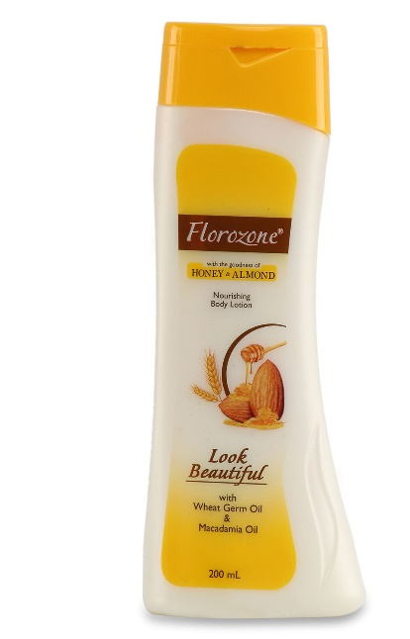
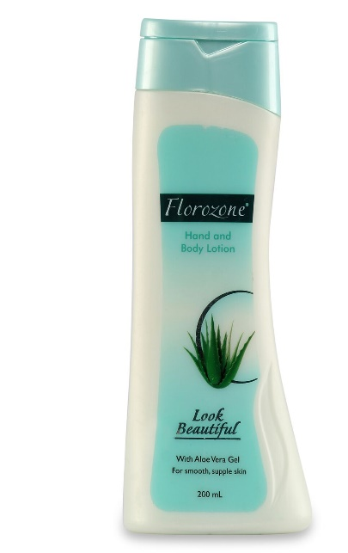
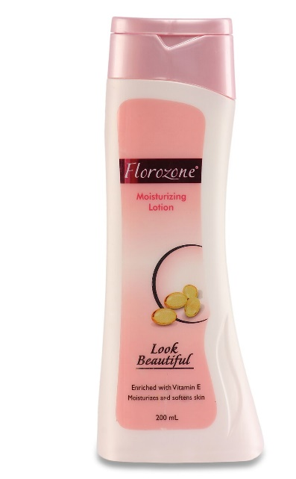
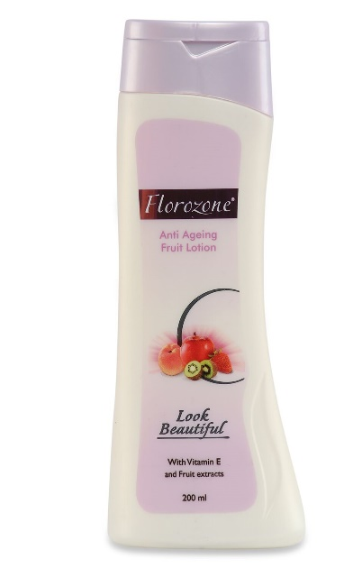

There is no uniformity in the brand logo. Logo colour varies as per the label colour. We want to have uniform brand logo for our skin care brand which stand out in the market and it should go well with different colour labels. The new logo should go well with all the packs shown above.
Brand Proposition: “ Your Skin Specialist “
Target group : Females 30-45 SEC A
Please check the brand logo of competitions as mentioned below

