Ingredients:
Pumpkin, Coconut Cream, Vinegar, Habaneros, Fatalii Medley, Butter, Garlic, Peppercorns, Salt

No Artificial Additives

Refrigerate after opening

Pimp’d Pumpkin
Chilli Sweet
Small Batch Craft Sauce
250ml

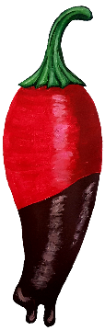
Produced and bottled on the Sunshine Coast

Batch Number:

Best Before:

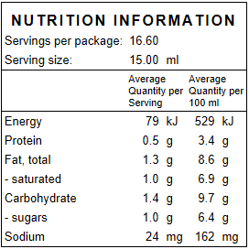




ChilliSweet.com.au

Based on the average
adult daily intake

