EliteHUD website redesign

Technology: preferable bootstrap, but not critical
CrossPlatform: Desktop/Mobile

Pages:
- Main (Current https://elitehud.com/)
  - Video, Room list, Features, Price, Contacts
  - Partner section (whom we work with)
  - Documentation and FAQ links

- Login (Current https://elitehud.com/Login/Login)

- SignUp/Password recovery (https://elitehud.com/Signup/Signup, https://elitehud.com/Login/RemindPassword)

- Dashboard (Dashboardscreen.png)
  - License token (unique and assigned per customer). Need an option to copy to clipboard from Dashboard screen.
  - Download link for latest product version.
  - Subs end date to display
  - Manuals FAQ links
  - Buy and renew subscription
Notes: Group everything related to subscription into one logic block on the screen.

- FAQ (https://elitehud.com/Home/FAQ).
  - Simple and comfortable in usage faq.

- Payment screen (BuySubsScreen_1.png, BuySubsScreen_2.png, BuySubsScreen_3.png)
Notes: Combine all the steps into one screen.

Make download trial which leads to registration!

Dashboardscreen.png

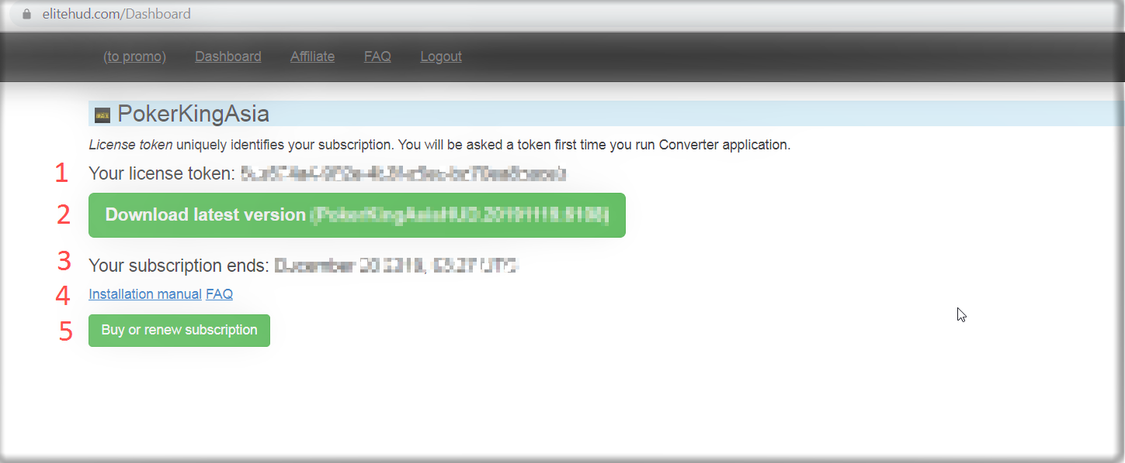

BuySubsScreen_1.png

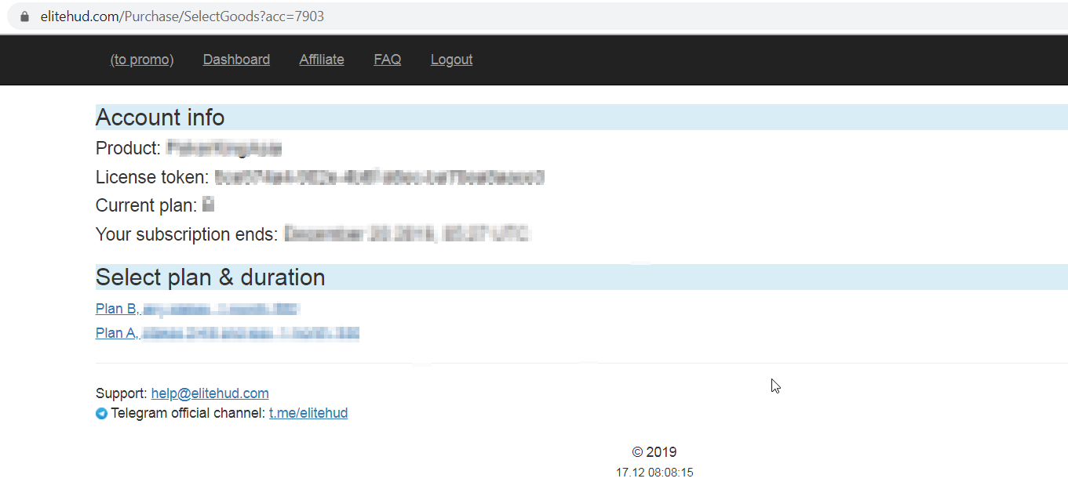

BuySubsScreen_2.png

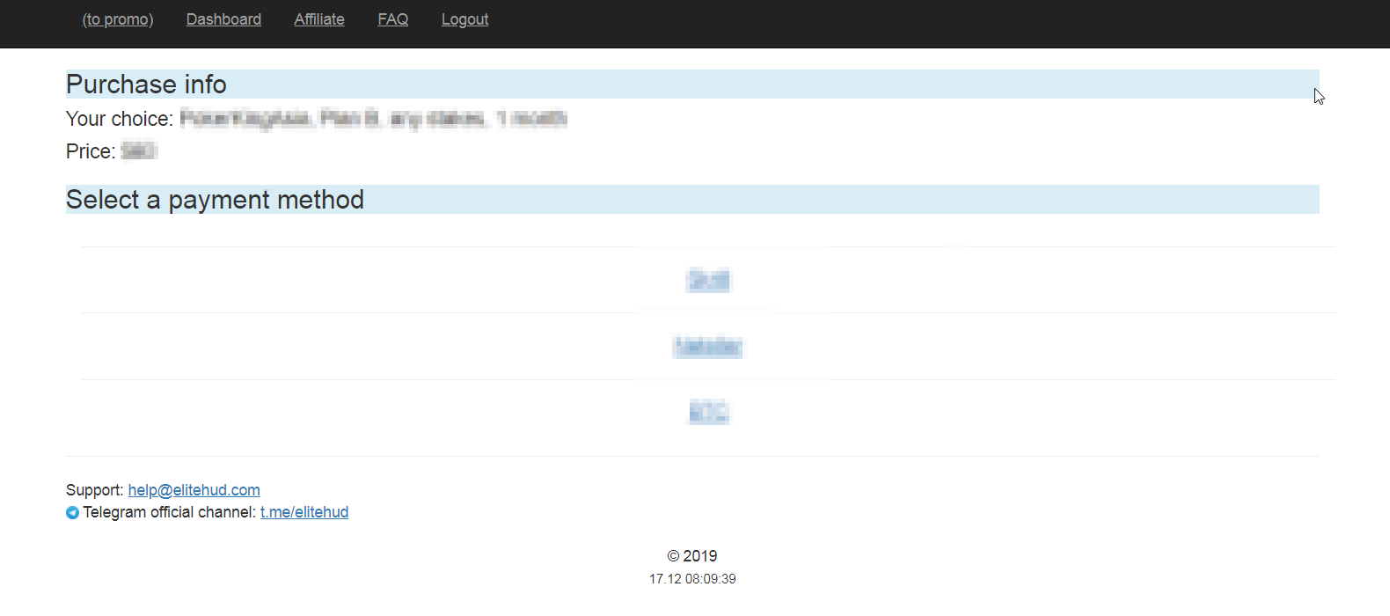

BuySubsScreen_3.png

