Size: 24”x36”, Vintage banners and script font like pictures attached.
White background with just a little bit of accent color.

SCRIPT:
They say, “Laughter is the best medicine!”
Well, we think
Tylenol
Ativan
MSO4
Lasix
Nitroglycerin
Haldol
Imodium AD
Albuterol
Vancomycin
Insulin
&
Oxygen

Just might be what you want more in certain situations.
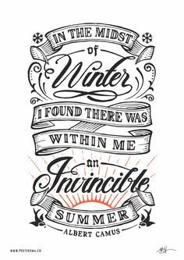
Nursing Pharmacology Concepts
Maryann Godshall, PhD, MSN, RN, CCRN, CPN, CNE
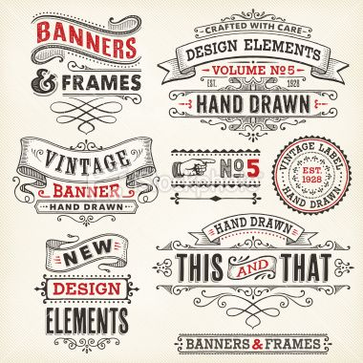
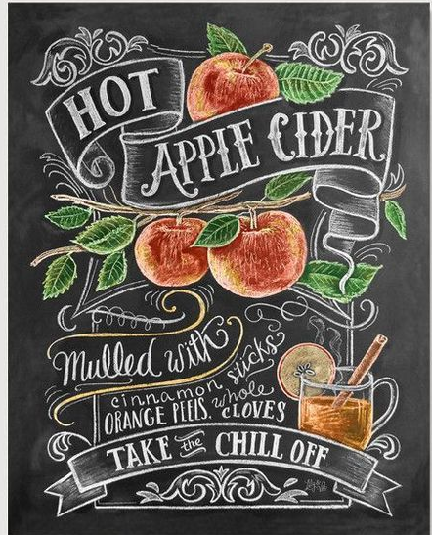
Clinical Professor

