Design Briefing for book cover for I Can Eat Boogers Too

Front Cover:
Title: I Can Eat Boogers TOO
Tagline: A collection of parenting stories to warm the cockles of your heart... and wet the tip of your finger.
Authors Name: Daniel Prokop

The Spine layout:
Taking it With You at the top of the spine running down the spine and then Daniel Prokop and then at the bottom of the spine the Continuum Logo (file for downloading in briefing area)
Back Cover:
- Top of the back Cover is the following testimonial:
“A warm, laughter-filled, no-holds-barred journey through the everyday glories and agonies of fatherhood ... Look in this mirror and feel a bit less alone, like it is all even more worthwhile.”
Robin Grille, author of Heart to Heart Parenting
Underneath this.

- Heading followed by a list-
A Collection of Twenty-Five Inspiring Parenting Stories including:
I Love you Like a Rock
The Power of Please
Wrestling Dad for the Win
Parent Teacher Teacher Child
The Cuddle Bank
Twinkle Twinkle Little Eyes
Where Has My Pedestal Gone?
Legal Eaglets
I said Housework not Hogwarts
The Boy Who Punched the Sky
Then He Was Five
When Kissing it Better Stops
Sand is for Sharing
Great Parental Expectations

- Heading Followed by quotes.
What Critics are Saying:
“Some slick writing!” “Don’t blow your chance to read this!” “Did I pick the book? Or did the book pick me?”
Photos or illustrations:
- I have some photos available: low res versions below or illustrations? Your choice
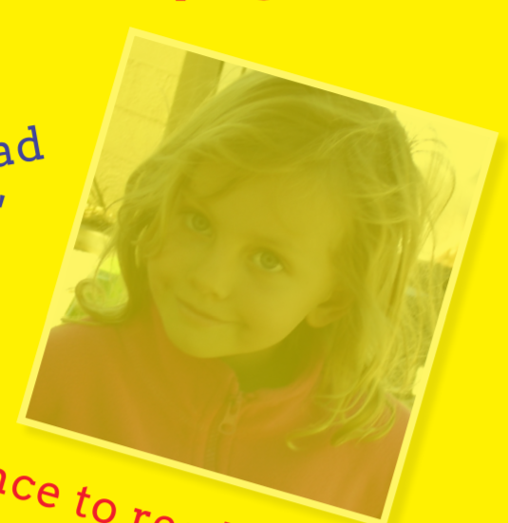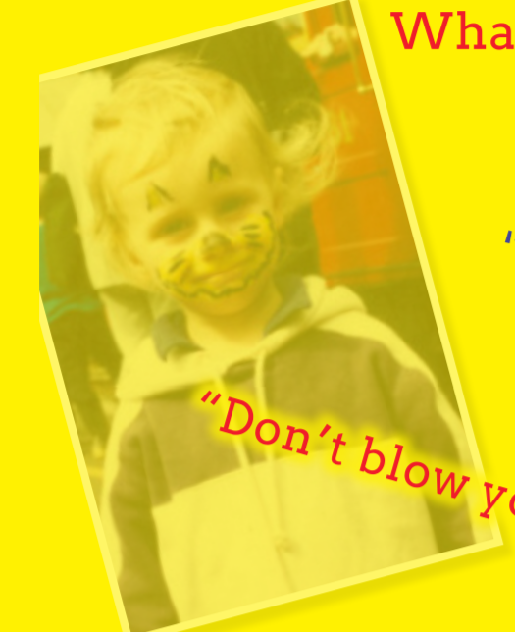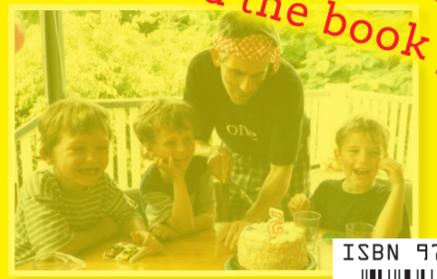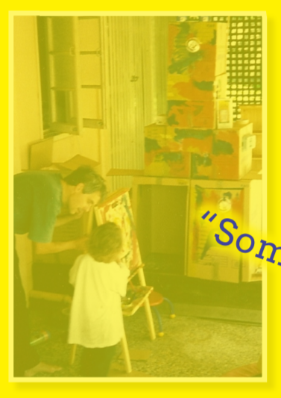
The bottom two photos relate to stories in the book
I am not attached to particular colours – would like it to stand out on a book shelf.

