EXAMPLES of LOGO likes from the Web


Like the 3 D spire logo and the Text fonts


Like the logo ( spire as viewed from above) and the font

Simple, clean and not overwhelming
Like the EN and Terra font contrast – (enSpire)
again simple with a splash of color and contrast

Liked the spire logo and if look at it sideways can almost see an E?


Again liked the spire and the 3 D effect, and also the structural strength
If you look at it you can also see an embedded E on 2 sides
EnSpire Environmental Inc. (EEI)?
Would like to see an example with some tessellation in it too?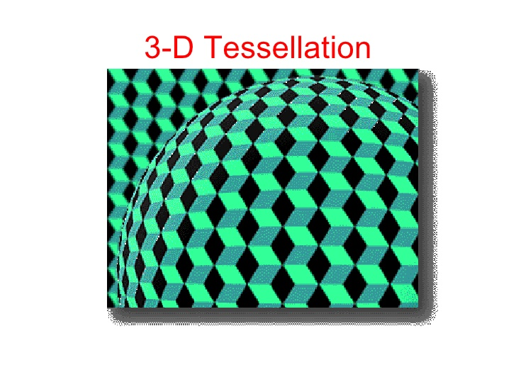
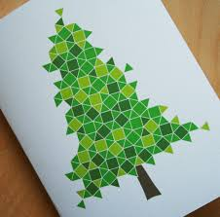
Would prefer to see tessellation where it takes the pieces and transforms them into something recognizable Reinforcing : Taking your needs and data and assembling them to deliver you a ‘clear picture’ project result.

