
Toddler Daily Care Record
Name: _____________________________________ Date: ________________________
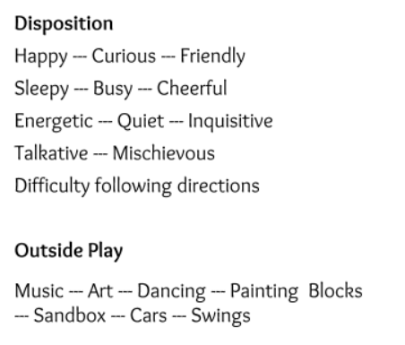
CAREGIVER USE

AM Snack All Most Some None
Lunch All Most Some None
PM Snack All Most Some None
Nap Time: 1 hr. 1-1/2 hrs. 2 hrs.
I was Quiet I didn’t feel like resting

Diaper Checks:
D: Dry W: Wet BM: Bowel Movement E: Effort P: Pee in Potty BMT: Bowel Movement in Potty
6:30 | 7:00 | 8:00 | 9:00 | 10:00 | 11:00 | 12:00 | 1:00 | 2:00 | 3:00 | 4:00 | 5:00 | 6:00

Your child needs: _____________________________________________________________
Today I had fun:

Caregivers Observations: ___________________________________________________________________________________________________________________________________

