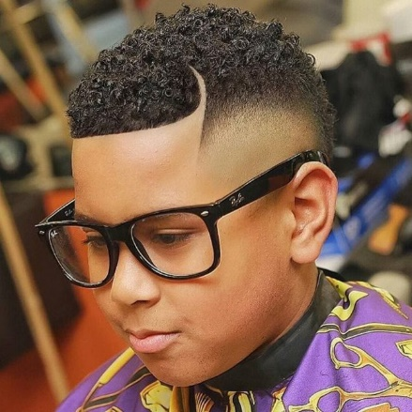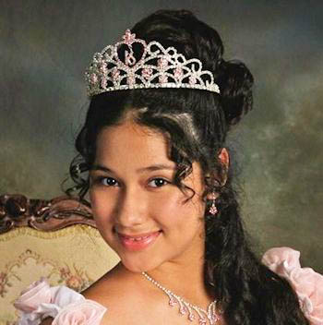
Figure 1 Black Boy with fade haircut
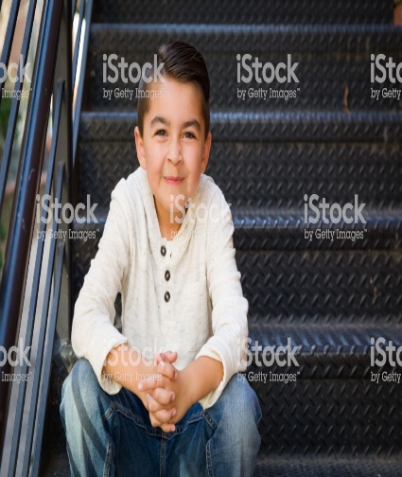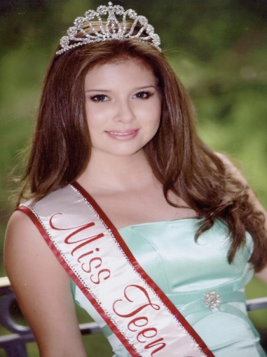
Hi. I would like a cartoon style design of a group of five children wearing crowns. The kids should be between the ages of 10-16. The faces should show lots of expression. There should be:
1 black girl – Her crown is the style that I like. Each crown should have Jade (green) color stones in them
1 black boy with glasses
1 white girl w red hair
1 Hispanic boy
1 Asian girl
All of them should smile and wear a crown on their heads. The black boy should have a fade hair cut so his crown may be tilted to the side. See pictures for example of haircut. Please let the skin tones vary but be natural looking. I gave two examples of black girls. I like the braids of the 2nd one but the eyes are too big and face could be more round.
The characters will be on t-shirts as well as in a children’s book. I would like to do some simple animations soon so please be mindful of that when creating.
I included a sample of the castle and grounds. Please do not make the castle pink. I do like the style of the picture. You can choose clothes for the kids. They are modern and are royal. Please make them neat and clean looking. Thank you very much. The castle flags should be green as well.
Figure 2 White Girl with red hair
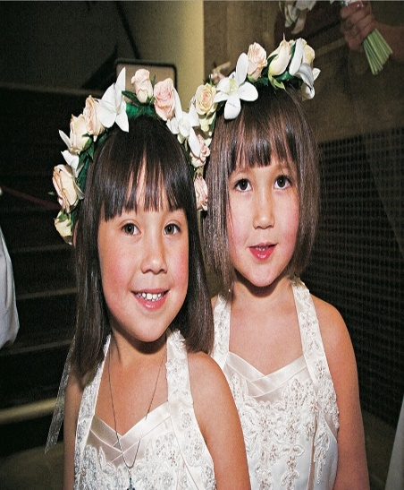
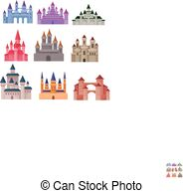
Figure 3 Example of Castle and grounds

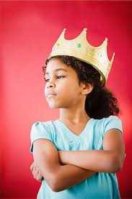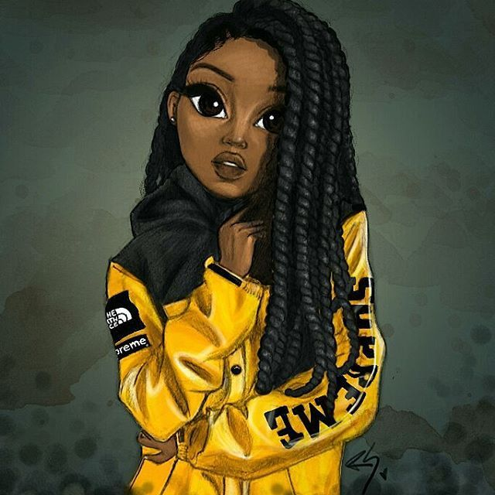
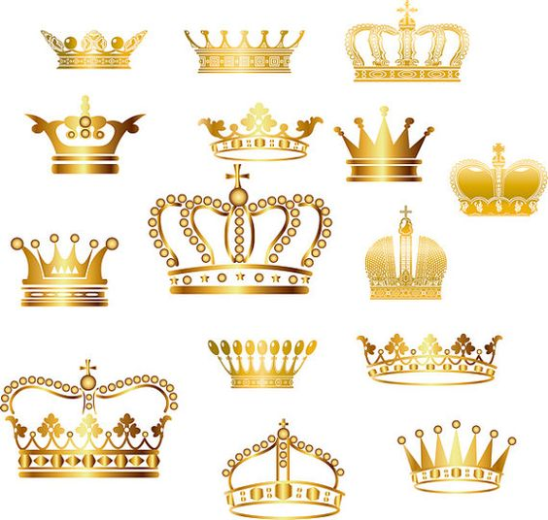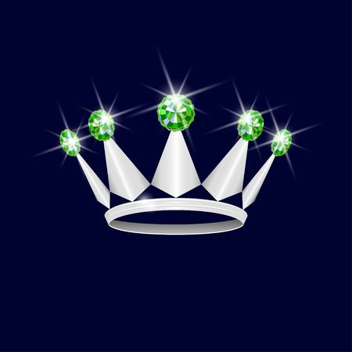
4 I like the green stones if crown was gold

