Maybe figure 1, 2, 3 can have same style and figure 5 should use the same color.

Figure 1
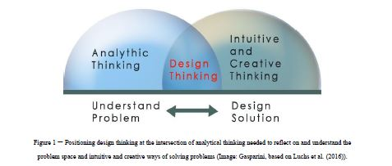
Figure 2
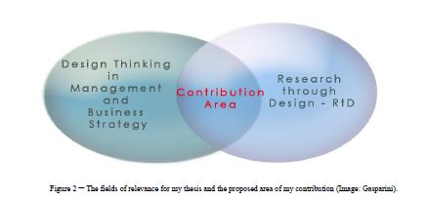

Figure 3
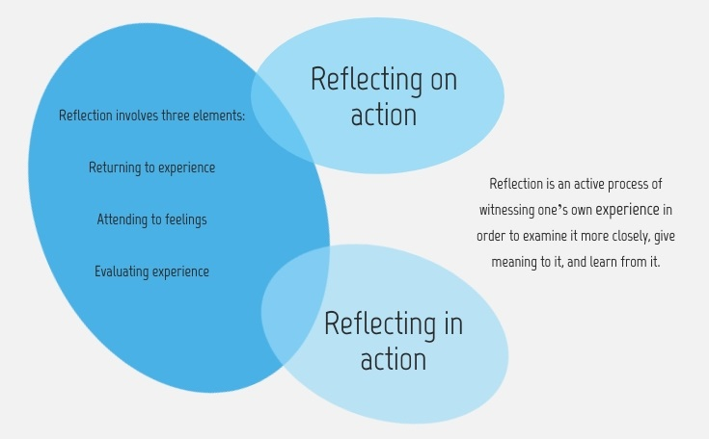

Figure 4 - Se Picture 14 as inspirasjon
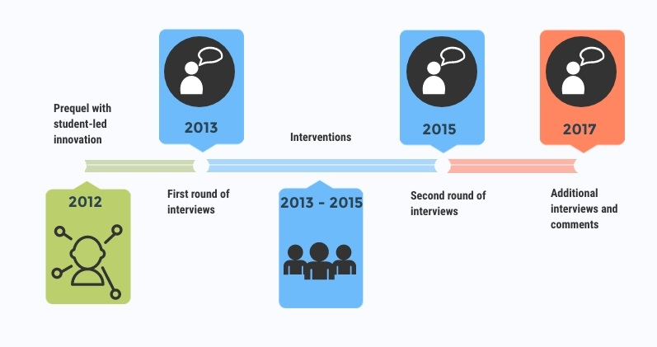

Figure 5 – overview of my research
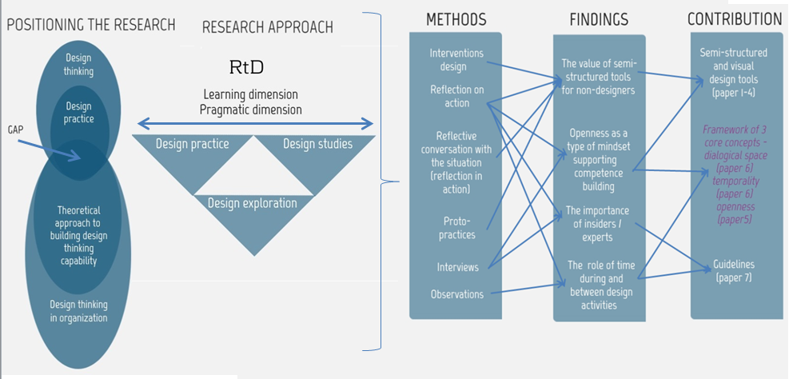

Picture 14 is an example (I used visme) and cannot be changed
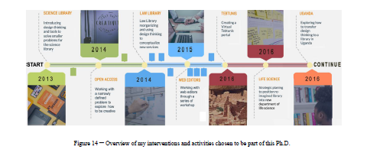

Each chapter has this type of picture and can be used as inspiration



