Design Objectives | Product types | Target group/sample designs we like | How do we want our customers to feel about our products | Why we think our customers will buy our products | Somaliland Symbols and artefacts
- Aim: Inspire people who identify themselves as being from Somaliland, or of Somaliland heritage, and those who sympathise with or interested in Somaliland  - Differentiation from the competition: We compete in quality (Quality designs, quality garments, quality service)  - Geographic Locations: North America, UK, Europe, Australia, New Zealand, and Somaliland (East Africa) | T-shirt | Primary Male: 15-35  Secondary: male 36-55 | Quality designs,  settled messages, patriotic, inspiring, positive and optimistic, shows strengths and self-confidence, expresses identity (settled), smart! Captures the imagination of young people | The art work needs to enable customers to express, celebrate and promote their identity. | The art work must be inspired by, or incorporate the following symbols and artefacts  - Somaliland flag  - Somaliland Emblem  - National day: 18 May 1991  - JSL: short form for the Republic of Somaliland in national language (Jumhuuridda Somaliland)  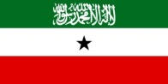  
 | Caps: Basketball& snapback | Primary Male/Female: 15-35  Secondary: male/female 36-55  Design examples I liked  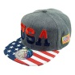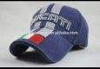  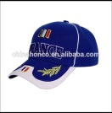  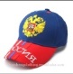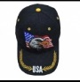  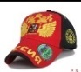
 | Beanies | 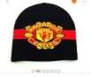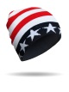  Primary Male/Female: 15-35  Secondary: male/female 36-55
 | Men’s Scarf (fan) | Primary Male/Female: 15-35  Secondary: male/female 36-55  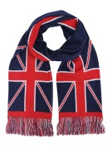
 | Fashion Scarf –square (women) | Primary Female: 15-45  Secondary: female 46-55  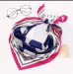  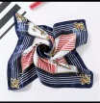
 | Scarf (women) | Primary Female: 15-45  Secondary: female 46-55  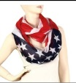  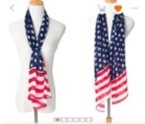
 | Polo shirt | Primary male: 25-60  Secondary: male 15-24
 | Our Logo | 