The following logo examples are NOT in any particular order. NOT AT ALL.
I will attempt to speak to each one individually so you can pick up some of the likes and do not likes about each one.
There are seemingly three directions we can go largely:
HC logo along with name, HOPE as a logo or anchor or some other symbolism like sunrise, etc.
We are revitilizing the church and are not looking for super religious looking work but would be open to integration of cross possibly. Clean, bold and modern.
Do not misread any of my comments as loving one over the other. We are still pretty open, but this gives some good direction of thought I think. Thanks! Pastor Nathan
I ran across this tonight and it makes me think leaning towards using a H or HC round logo, it could be used inside the word HOPE in proper settings. Like this:
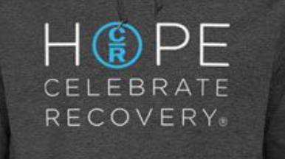
Still open to everything I sent, but this is one reason the round logo may be good, not to mention it fits well in social media avatars and such.
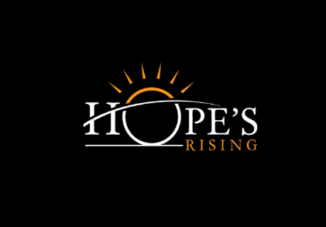  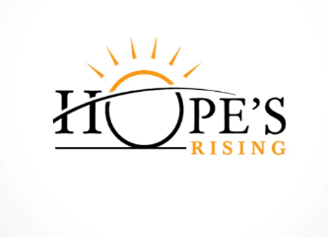 | Really like the look of this if using the word HOPE. Would need a bolder more modern font, but like the two colors and cross over from H to make sunrise is cool. Then “rising” would read “church”
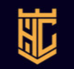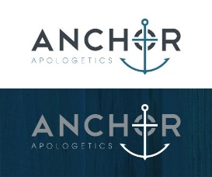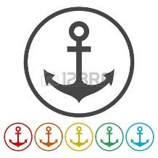 | Like the yellow one but it is Too harsh  Too pointy  Take out lines in H  Down rod for anchor  Possible cross
 | H needs to be stronger and be on top of C
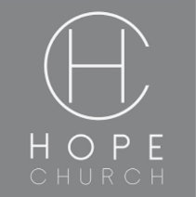 | Again, too thin, but simple and clear. BUT it is the actual logo of a church now
 | Too thin but do like the cross stand out for alternate color  Incorporate C into outer circle. Extend cross bottom and top so it lines up with right side of H
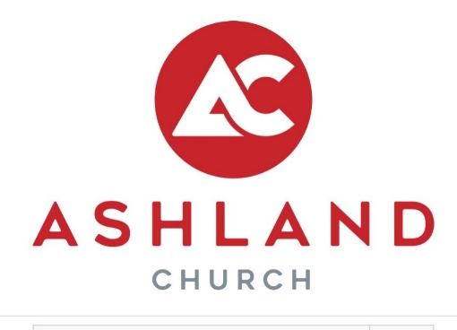 | The thickness and boldness of this is really nice. I would love to see something like this with HC. The kerning of ASHLAND is nice too

