HOME page

Could you please remove this whole block – OUR CLIENTS SAY
as we currently have no reviews

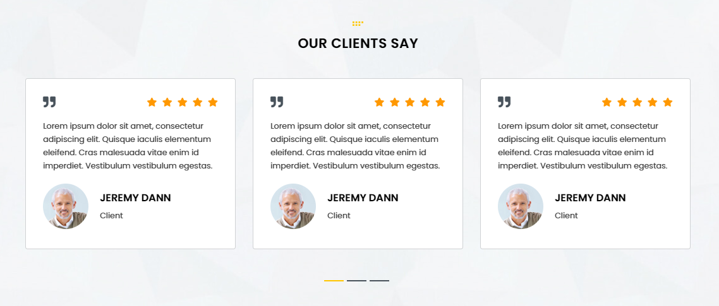

d
ABOUT US page

There's a space missing here between "we exist.Our team". It should be: "we exist. Our team"

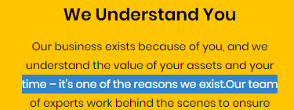

BENEFITS page

There's a space missing here:
"completed -on time" it should be: "completed - on time"

And a space missing here:
"budget.Our" it should be: "budget. Our"

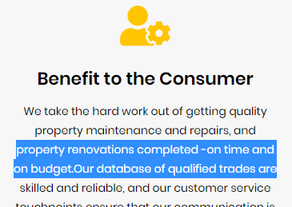

There's a space missing here:
"whole way–from the" it should be: "whole way - from the"

