BENEFITS page

Please remove the word "And" so that it reads "Because we only use"

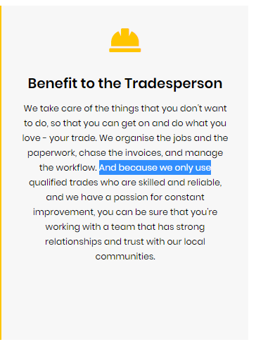

ABOUT US page

It's missing a space here, it should be "we've built".

