Explanation for DesignCrowd - Cover for 2020 Activities Guide

We would like a background of black and white images that are repeated throughout the background. (See other attachment for a sketch of what we would like.)

All of the images need to be black and white and can be a logo-type style (see the 2 examples below and other attachment):



We want a big red magnifying glass in the middle of the page that distorts the images in the middle as if they are being viewed through a magnifying lens.

At the top of the page we would like it to say either “City of Grand Terrace Activity Guide” or “City of Grand Terrace 2020 Activity Guide”

Here is a list of “common” or “generic” items we would like in the background:
Baseball, Soccer, Basketball, Swimming, Hiking, Boys and Girl Scouts, Books and park bench.

Here is a list of items and images that are specific to Grand Terrace. We would like something that looks similar to these or exactly the same but in black and white:

Old style bicycle
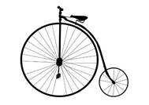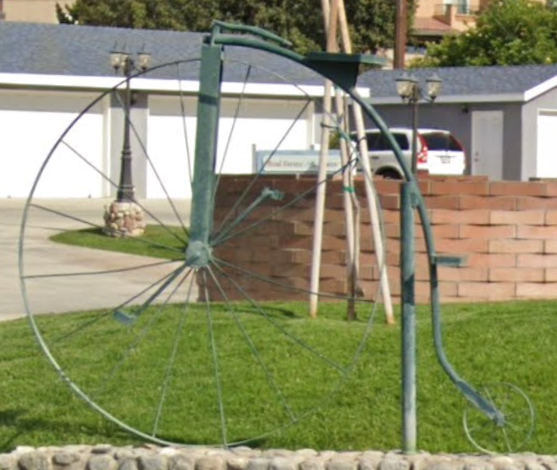

The Library and City Hall building

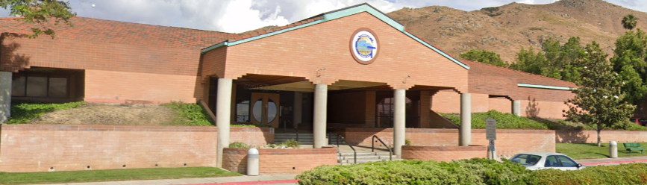

Foundation of Grand Terrace

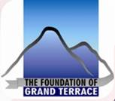

Veterans Wall of Freedom

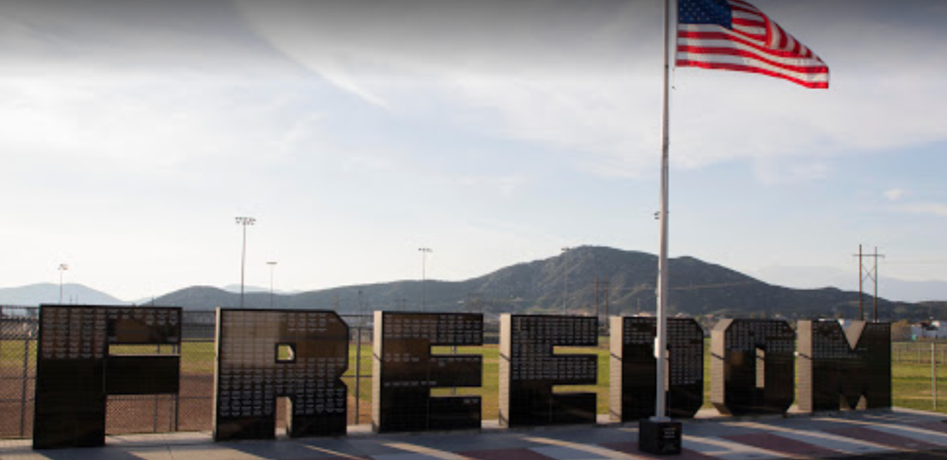


Beehive – These beehive sculptures can be found throughout the HoneyHill Neighborhood in Grand Terrace

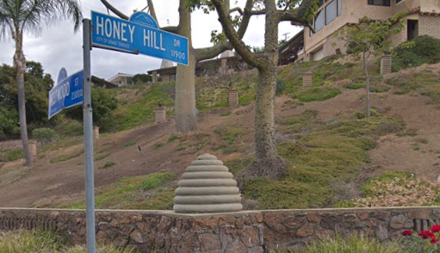
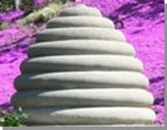

Blue Mountain logo
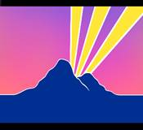

Grand Terrace Dog Park

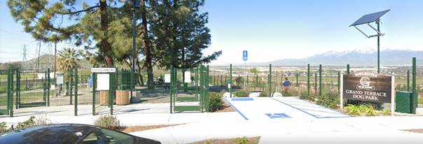

Barton Road – this is one of the main streets in Grand Terrace. We are also in the midst of a roundabout project on Barton Road and the I-215 Freeway.
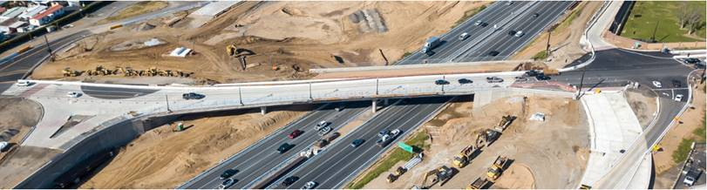
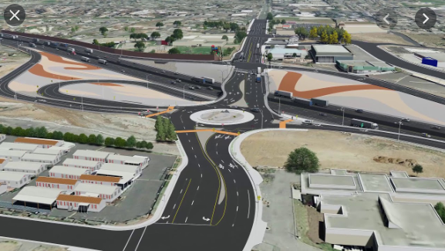

Kiosks – We have Kiosks where we put up upcoming events the City is having around town. Here is an example:
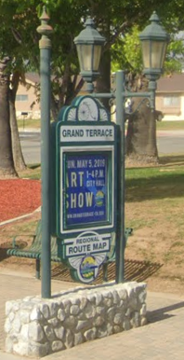

Labyrinth – We have a couple of Labyrinths in Grand Terrace Below are some images:

