Menu Design Brief

Company Name:
Seletar

General Business Description:
Singapore Restaurant Based in New Plymouth

Description of Menu:
We are opening a new Singapore themed restaurant here in New Plymouth. We need a customizable menu designed for the restaurant.
I HAVE ATTACHED A FEW MENU EXAMPLES THAT WE LIKE AND THEY CAN BE FOUND AT THE BOTTOM OF THIS DOCUMENT
Our restaurant will be created to replicate the tropical and modern environment of Singapore. The aesthetic and feel of the restaurant will be natural, relaxed and tasteful. The main showstopper will be the food complimented by the superb level of service.

Colors
We want the menu to match the colour pallet of our logo (Black & White) this doesn’t mean that we aren’t open to using other colors in areas however want the menu to be a clean as possible to sticking to these colours should allow for this.

Images of Singapore food:
It would be good to include photos of the food in the menu design however we do not want these images to distract from the overall menu design so if you feel that this might be happening then we would rather you do not include this type of imagery into the design

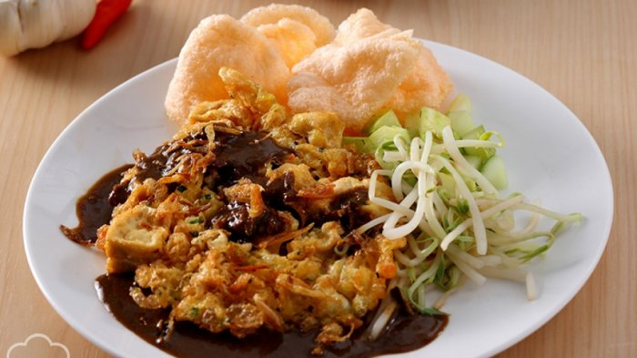
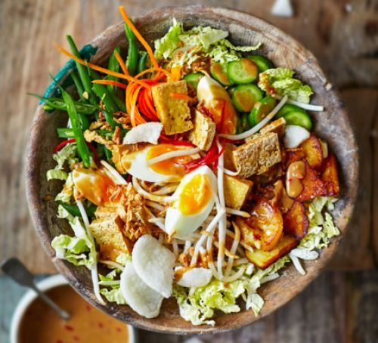
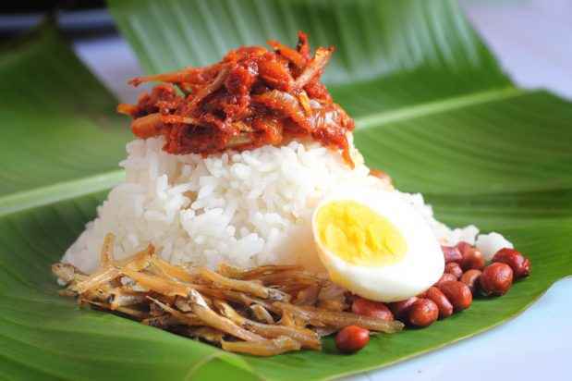

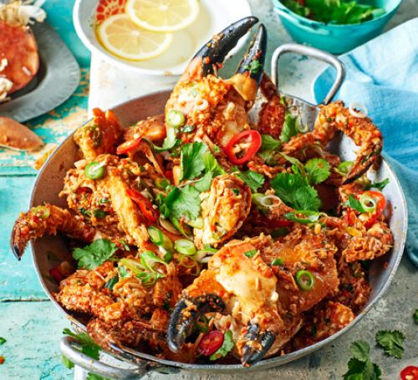

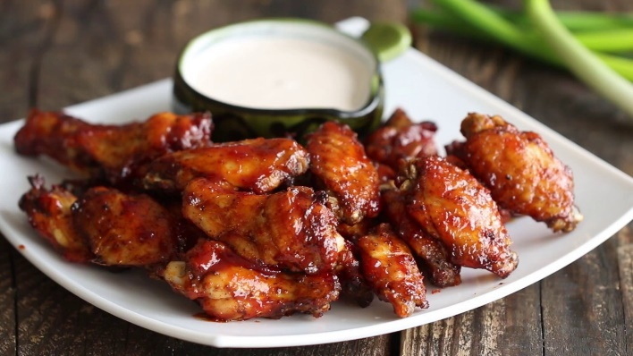

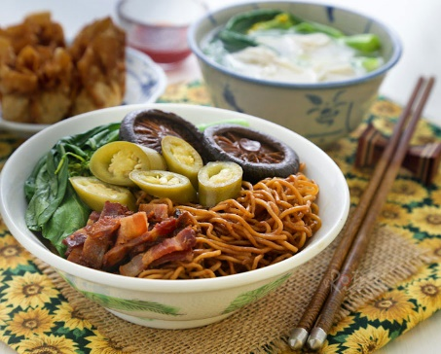
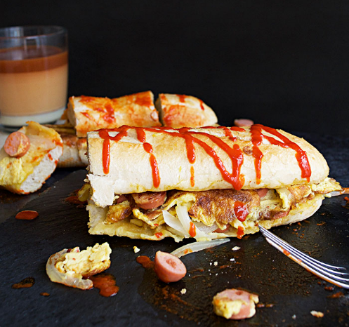

Size
We don’t really know a size or layout that would suit so this is entirely up to you how you design the menu size and layout however we don’t want a massively long and complicated menu design



MENU
Starters
Bagedil (potato patties) V ( 3 pieces ) $3
Fried Mashed potato patties with fresh cilantro, spring onions & spices coated in flour and egg
Tahu Telor (tofu with egg ) V $10
Fried spiced flour coated tofu drenched in egg, topped with satay sauce, crushed nuts & fresh sprouts.
Epok Epok (Curry Puffs) ( 3 pieces ) $5
Malay style empanadas stuffed with choice of :
- Chicken curry
- Fork tender beef
- Curried potatoes & seasonal veggies
Pakora V / Vegan $5
Chickpea, red onion and potato fritters in a mildly spiced besan (chickpea flour) batter accompanied by a sweet tangy tamarind dip
Chana Vada V / Vegan ( 3 pieces ) $5
Crunchy lentil fritters with onions, spices & curry leaf
Fried Wonton ( 8 pieces ) $10
Stuffed with choice of marinated spiced chicken / pork / pickled veggies with sweet soy dip
Gado Gado Salad V / *Vegan options available $12
A delicate salad of thinly sliced chinese cabbage, cucumber, beansprout, potatoes, french beans tossed in peanut dressing with boiled egg & marinated prawns.
Satay ( 6 sticks ) $12
Grilled aromatic chicken / beef or tempeh (soy beans) on skewers accompanied by ketupat (rice cakes), cucumber, onions & Singapore satay gravy
BBQ Chicken Wings ( 5 pieces ) $15
Singapore style soy marinated BBQ chicken wings made to order with sweet chili dip

Fried Carrot Cake $10
Savoury steamed white radish cake stir-fry with prawns & egg drizzled with sweet dark soy sauce
Roti
– made famous in Taman Serasi Singapore $15
Baguette loaf grilled with a topping choice of curried chicken / spiced beef or seasonal veggies cooked with egg and drizzled with chili sauce
Roti Prata ( 2 pieces ) $10
A traditional crispy street food flat bread accompanied with choice of chicken or veg curry for dipping
Roti Jala - Malay netted crepe $15
Flour & egg based batter spiced with tumeric and cumin accompanied with choice of chicken or veg curry
Murtabak - stuffed prata $15
Flour based crispy flat bread stuffed with choice of double cooked chicken curry, sauteed beef or seasonal veg curry
Noodles
$15
Wonton noodles tossed in sweet dark soy sauce, sesame oil topped with pickled chili, cucumber & broth with choice of bbq pork, chicken or prawns and fried crispy wontons
Seafood mee goreng $18
Wok fried Malay style egg noodles in a homemade chili paste with prawns and squid topped with fried egg
Veggie mee goreng V $15
Wok fried Malay style egg noodles in homemade chili paste with seasonal veggies & tofu

Char Kway Teow $15
Wok fried rice cake strips in sweet dark soy sauce, fish oil, chili paste with seafood topped with beansprouts
Laksa Ala Katong Singapore $18
A Peranakan style prawn based broth noodles with prawns, squid and mussels topped with boiled egg & fried tofu cubes

Hor Fun Noodles $16
Flat rice noodles stir fried with dark sweet soy sauce and a choice of seafood or pork in a silky egg gravy
Rice
Singapore Chicken rice (Family style sharing)
Half chicken for 2 pax $20
Whole chicken for 4 pax $35
The Singapore classic - aromatic roasted chicken with fragrant rice cooked in a chicken broth accompanied by seasonal veg in oyster sauce and ginger sweet chili dip
Nasi Lemak 2 pax $18
Jasmine rice cooked in coconut cream infused in pandan leaves, comes with condiments of fried egg, ikan bilis, toasted nuts, crispy fried chicken and shrimp based sambal
Fried Rice $18
Chinese style fried rice with choice of chicken, beef or veg in sesame oil & fish sauce
Black Pepper Rice $18
Fragrant white rice accompanied by a choice of tender beef, chicken or seafood in a black pepper sauce

Sharing
Famous Singapore Chili Crab with Mantou Bun
Whole crab cooked wok style in a homemade tamarind spiked chili paste and egg sauce accompanied with Mantou buns for mopping up the gravy
**Seasonal pricing**
Hot Plate Tofu *Vegan options available $15
Silken tofu on egg, leeks, onions with oyster sauce
BBQ seafood in banana leaves $18
Choice of marinated seasonal fish, prawns or stuffed squid in wrapped banana leaves
Malay Rendang $25
Beautiful rich beef curry, slow cooked with asian spices, lemongrass and kaffir lime leaves with a touch of coconut cream

Sambal Kang Kong $10
Wok fried Water spinach tossed in belachan paste
Steamed Local Fish $seasonal pricing
Freshly steamed with sesame oil, fish sauce and oyster sauce in chili, onions, ginger, leek and garlic
Sweet & Sour Seasonal Fish $seasonal pricing
Crispy catch on a sweet and sour sauce with flash fried capsicum, onions and pineapple
Seasonal veggies in oyster sauce *Vegan options available $12
Stir fried seasonal veggies tossed in sweet oyster sauce topped with fried shallot

Desserts
Apam Balek $10
Malay style sweet pancake filled with crushed toasted nuts, caramelised onions accompanied with ice cream and caramelised condensed milk
Kueh Dadar $10
Grated coconut cooked in gula melaka (palm sugar) and wrapped in a pandan infused crepe
Sago Gula Melaka $10
Creamy tapioca pearl pudding served with thick caramelised palm sugar
Kueh Seri Muke $10
Steamed layer of Glutinous rice and pandan infused coconut milk topped with toasted desiccated coconut

