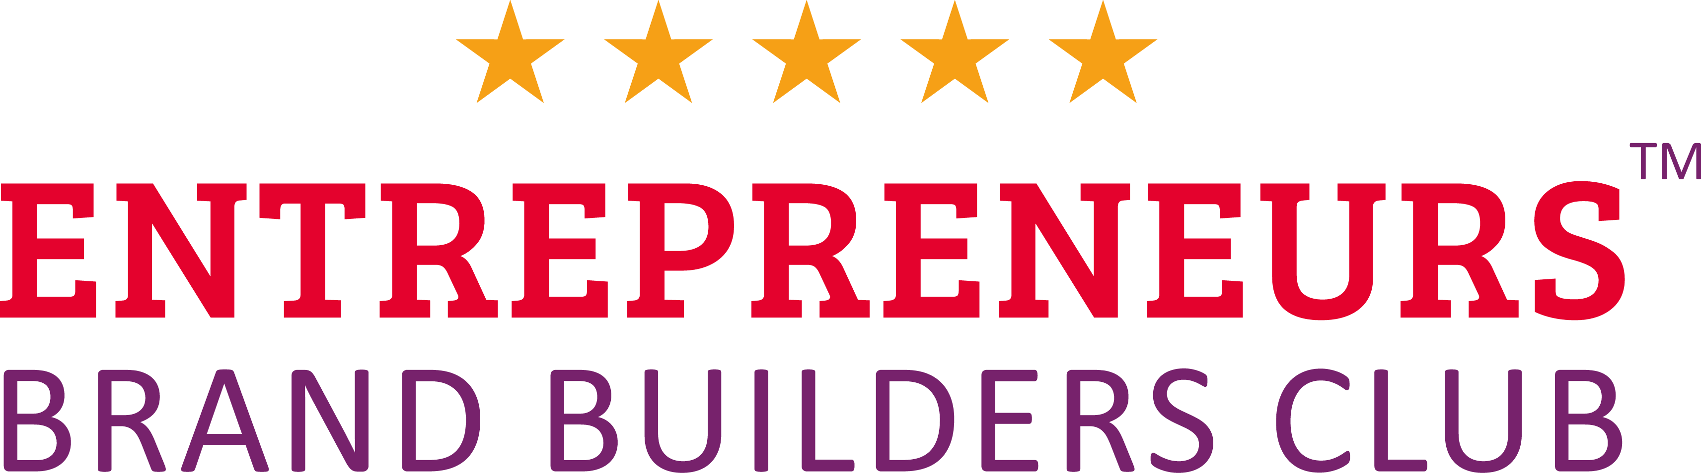

Your Branding Brief



About Our Company Blissful Being

Our Company Vision Is

I’m building Global holistic resource to transform stressed & overwhelmed people from run down to recharged and ready to enjoy life to its fullest.

Our Company Mission Is
I do this through easy to follow resources, mini-courses, products and retreats that will bring harmony and balance into your life, resulting in a dramatic transformation to your overall health, wellbeing and relationships.

Our Core Three Company Values Are

1. Harmony

2. Connection

3. Community

Our Ideal Customers Are…

Ideal Customer Profile 1:
- Mothers over 30 years old busy, managing family life and business
- Running own business
- They want to be calm, relaxed, patient, feel good, harmony
- They are interested in natural way of living, natural products, spirituality, meditation, holistic approach
- Like to learn, interested in personal development
- They are determined, ambitious and achievers

Ideal Customer Profile 2:
- Women over 30 years old
- They are interested in natural way of living, natural products, spirituality, meditation, holistic approach
- Want to relax
- Looking for balance, clarity, inner peace, harmony
- Want to learn how to manage they emotions

Ideal Customer Profile 3:
- Men over 30 very stress
- Want to relax
- They have a family with kids

The Top Three Companies We Respect Most & Want To Model The Success Off Are:

Louise Hay
- Louise Hay
- Abraham Hicks

- Marisa Peer

Who Are Our Top Three Competitors?

1 There are few companies with same name (Blissful Being) so I want to stand out
2 Dottera,
3 Young Living

Why Is Blissful Being So Different to Our Competitors?

- I would like for all my clients – the experience of joyful relaxation that is enveloping and nurturing, the feeling that you are coming home, to a place of healing
- We offer personalize products
- Easy access to all materials
- Easy to fallow tools
- I would like to help people and introduce them to the wonderful benefits of essential oils. I would like to ignite within my clients the same passion for essential oils that I have. I have created Blissful Being a place for people you so they can learn how to completely relax and recharge. At this on line space they can access tools resources and products created by someone who is passionate about, they well-being.
- By growing your new supportive roots, you can enjoy your blissful fruits
- I believe that the journey to being blissful is unique and individual. With a perfect mix of customized products, holistic tools, technics and natural products you can transformation your life from run down to recharged and feel amazing. Because is so good just to feel good.

A

The Best Benefits Of Using Our Products/Services Are…

- Feeling good, relaxed, calm, happy, inner peace
- Feeling important that now is your “Me time”
- Improving skin condition,
- Improving health

- Archiving clarity
- Getting knowledge of natural and holistic leaving
- Becoming better version of yourself
- Achieving harmony and balance
- Fending purpose
- Becoming creative, inspire and full of new ideas

The Core Areas Of Our Business Are …

- Holistic (Soul, Body, Mind), natural self-care mindset books
- Aromatherapy products
- Essential oils
- Courses
- Retreats

Words That Describe Us As A Company Are…

By growing your new chosen supportive roots, you can enjoy your blissful fruits

- Wellbeing
- Harmony
- Love
- Positivity
- Natural
- Trust

The Marketing Materials This Brand Identity Will Be Applied To Are…
- Product labels
- Banners
- Books
- Stationary
- Website
- Social media posts
- Stickers
- Posters
- Essential oils bottle label

The Fundamental Design Elements That Must Be Included As Part Of This Project Are:

- The Logo Design (I expect to see 3 design concepts to choose from)
- Letterhead and Compliment Slip Design
- Business Card Design (Make it unusual and not just a double sided card like everyone else)
- Social Media Profiles Design (Facebook timeline image, Twitter & YouTube background images)
- Email Signature Strip (Logo with contact details to go at the bottom of all emails)
- Brand Guidelines Document (To give any future suppliers who will use our logo)

About The Brand Design…

Suggested Typefaces:

- This brand is going to be aimed at a female target audience first but as well to men.

Brand Design Colours:

Based on the three colours you have been given by Sammy as part of the Brand Kickstarter process, please list them here for your designer to stick to:

Dominant Colour: [Pantone reference) …2583c, Lavender / Lilac -CMYK: C:47,M:71,Y:0,K:0 /RGB: R:155,G:95,B:163/ Web #9B5FA3
Secondary Colour: [Pantone reference) ……1585c……………… orange CMYK: C:0,M:68,Y:90,K:0 /RGB: R:237,G:107,B:37/ Web #ED6B25

Sub Brands To Be Designed As Part Of The Whole Brand:

The main parent brand name is: Blissful Being

This brand must be designed with
sub-brands (different aspects of your business), which are as follows:

1. Essential oils
2.Oracle card
3.Traning, courses workshops

Any Further Notes:

I have a logo already. I love that gold color. I want to keep the tree and whatever is around can change. To make this color was used:
Hex: #F2D9A99
RGB: 242, 218, 153
CMYK: 7, 13, 48, 0

Hex: BF9A29
RGB: 191, 154, 41
CMYK: 23, 34, 91, 11

