LOGO Graphic + Logo Font Fully Human Fully Alive Psychology and Counselling Relationship Centre
Tel.: (02) 9705 0065
Email:info@fullyhumanfullyalive.com.au Text/Call: 0419 000 000 0499 870 011
Across the Top Menu Tabs
How We Can Help Relationship Counselling Parenting Courses Our Team Contact
( Services)

Page 1

Who We Help
Fully Human Fully Alive Psychology and Counselling Relationship Centre is a team of highly trained professionals provide the ultimate in wellbeing treatment for children, teenagers, adults, parents and couples. We have a strong reputation for providing a warm and personalised service using research based approaches.
We are passionate and dedicated to helping you get what you want out of life, and we provide life changing treatment for many people, including those experiencing issues such as anxiety, stress, relationship problems. We specialise in Perinatal Anxiety, Parenting and Child issues, Couple Relationship and Men’s issues.

What to Expect

Sometimes people don’t know what to expect from the counselling processes. You may wonder if your issues are too complicated, or not serious enough, or worry that the things you’ll discuss will be so distressing that you’ll carry the pain around with you, long after leaving the session.
What people may not realise is that good therapy can be a joyful experience, despite the need to discuss stressful, sad or shameful things. There’s a beauty in developing insight and making choices from a place of awareness rather than habit or fear.
There have been lots of tears in our office, it’s true, but there have been even more “Aha!” moments when someone makes a connection between an old belief and a current behaviour. There’ve been quite a few laughs, and exhilarating moments when someone realises they’ve achieved real change.

If this resonates with you and you would like personalised support in your relationship, your parenting or just your life in general, please contact us by email or phone.
We look forward to helping you take that important first step to looking after yourself.

Couples

Treatment for couples over 18 years old. We work with married couples, people in life partnerships and same sex couples and provide counselling services to improve the quality of relationships.
View Services

Parenting

We work with parents to improve the quality of relationships between parent and child. We also work with new parents and parents who maybe suffering with post or peri natal depression.
View Services

Adults

Treatment for individuals over 18 years old. We work with men and women and treat a wide range of mental health issues.
View Services

Children & Teenagers

Treatment for individuals up to 18 year olds. We work with boys, girls, young adults and their parents and treat a wide range of mental health issues.
View Services

Page 2

Relationship Counselling for Couples
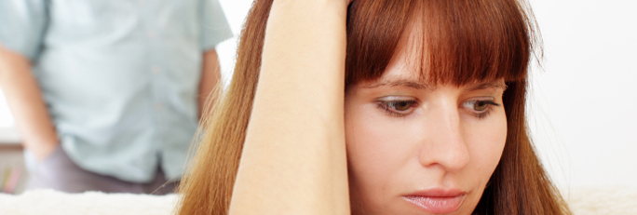
Fully Human Fully Alive Psychology and Counselling Relationship Centre offers experienced Relationship Experts to help you with any relationship issues you are facing.
Below is a list of issues we can assist you with. Please contact us if you have any questions.
Relationships can be one of the most enriching, joyful and rewarding experiences in life.
They can also be quite challenging. Whether you have particular challenges you are facing, or you want to double check your relationship has the key ingredients to living a full and happy life together, coming to therapy can be a positive step towards looking after your relationship.
Here are just some of the ways you and your partner can benefit from working with a therapist:
- General relationship or couples counselling
- Marriage counselling
- Pre-marriage counselling
- Parenting issues
- Dealing with affairs
Abusive relationships
Feeling Controlled
- Improve communication
- Manage arguments or conflict
- Separation counselling
- Resolving past issues
- Gaining a better understanding of each other
- Discuss future goals
- Renew common interests
- Spend more time together
- Balance self-care with the demands of family life and relationship time
- Increase intimacy and joy
- Have more fun together

Page 3

Parenting
Fully Human Fully Alive Psychology and Counselling Relationship Centre offers experienced Parent Attachment Experts to help you with any parenting issues you are facing.
Below is a list of issues we can assist you with. Please contact us if you have any questions.
Parenting can be one of the most enriching, joyful and rewarding experiences in life.
It can also be quite challenging. Whether you have particular challenges you are facing, or you want to double check your parenting style has the key ingredients to raising a confident and secure child, coming to therapy can be a positive step towards being a Bigger , Stronger , Wiser and Kind parent.
Here are just some of the ways you and the other parent can benefit from working with a therapist:
- General parenting issues
- Becoming a new parent
- Peri-natal anxiety
- Post-natal depression
- Grief and Loss
- Improve communication
- Manage arguments or conflict
- Separation counselling
- School refusal
- Chaos in the morning routine
- Open communication with my children
- Taking charge
- Child more comfortable at school
- Balance self-care with the demands of family life and relationship time
- Teen years
- Handle and resolve problems and conflict more easily
- Child can enjoy improved and closer relationships with their siblings
- Develop a better understanding of your child’s needs
- Strengthen the bond with your children
- Have more fun together

Page 4

Child & Teen Health Issues We Treat
​
Fully Human Fully Alive Psychology and Counselling Relationship Centre offers experienced Well Being Experts to help your children with any mental health issues they are facing.
Below is a list of issues we can assist you with. Please contact us if you have any questions.

Academic performance
ADHD
Adjustment Disorder
Alcohol & drugs
Anger management
Anxiety and phobias
Asperger’s Syndrome
Attachment problems
Bedtime and sleep problems
Bullying
Conduct disorder
Depression
Eating problems
Emotion/mood regulation problems
Feeding problems
Grief and loss
Non-compliance
Obsessive Compulsive Disorder (OCD)
Oppositional Defiance Disorder
Parenting skills training
Phobias
Post Traumatic Stress Disorder (PTSD)
Procrastination
Relationship difficulties
School problems
Self-esteem problems
Self-harm
Separation Anxiety
Sleep problems
Social anxiety and shyness
Suicidal thinking
Temper tantrums
Weight and body image issues
Worry

Page 5

Adult Health Issues We Treat


Fully Human Fully Alive Psychology and Counselling Relationship Centre offers experienced Well Being Experts to help you with any life difficulties you are facing. Below is a list of issues we look forward to assisting you with. You are welcome to contact us if you have any questions.
Adjustment
Alcohol & drugs
Anger management
Anxiety and phobias
Assertiveness training
Bipolar Affective Disorder (BPAD)
Borderline Personality Disorder (BPD)
Brain injury
Bullying
Burnout
Cancer support
Depression
Dementia
Divorce & separation
Domestic and family violence
Eating disorders
Grief and loss
Health and lifestyle problems
Life coaching
Marriage counselling
Mood problems
Obsessive Compulsive Disorder (OCD)
Pain
Parenting issues
Perfectionism
Personality disorders
Phobias
Post Natal Depression
Post Traumatic Stress Disorder (PTSD)
Procrastination
Relationship difficulties
Self-care
Self-esteem
Self-harm
Sexual assault
Sleep problems
Social anxiety
Stress management
Time management
Weight and body image
Work-related difficulties
Worry

Page 6

Courses
Fully Human Fully Alive Psychology and Counselling Relationship Centre offers Courses with experienced Psychological and Human Change Facilitators to help you with any issues in being human. These 5 week courses can be a fast track and engaging way to help you gently explore yourself and /or your relationship.
Below is a list of some of the courses we conduct. Please contact us if you have any questions.
Parenting
Couple Communication
Anger management
Anxiety – How to Beat it or Accept it
Assertiveness training
Circle of Security
Why Does He Do That ?
Change Management
Bullying
Assertiveness for Managers
Team Building
In House Courses

Page 7

Our Team

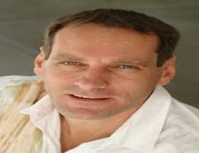

Derek Ebbs MPsych, BcHc, ACMA, CGMA
Relationship Psychotherapist

Derek is a Relationship Psychotherapist specialising in the Attachment bond between parent and child and the implications for adult relationships – the attachment bond between couples.
His Masters research ‘Intimate Passionate Marriage’ was in the area of Intimacy in Relationships.

My special interest and research paper on attachment relationships consolidated my view that a Systemic approach to the individual, couple and family interlinked with Attachment theory can empower the person to empathically accept their situation and enable lasting change to emerge. I believe that a healthier, balanced couple and family can bring so much more to an individual and the couple and the nurturing can be reciprocal and growth enabling. An available and responsive partner creates a holding environment for intimacy to grow securely.

Derek has further studied with Kent Hoffman (one of the originators of Circle of Security) the advanced subtleties and core sensitivities of the anxiety present in a marriage where circular dissatisfaction has become the pattern. This may be felt as resentment, anger, distrust, sexual frustration, fear and loneliness.
Derek has helped many couples and parents (and hence children) move from a disorganised unsatisfying relationship to a more stable secure thriving and safe environment.

Derek also works with men who are abusive and controlling in their intimate relationships.

Client Comments:
We were stuck; quite simply, you unstuck us.

Derek has a presence where he therapeutical holds the couple in front of him.

Your skill in uncovering the real issues was impressive.

You non-judgmental open stance made me feel heard and safe.

I now know I can Be With my anxiety

I can’t believe the difference in my child…and me!

You can contact Derek directly on:
E. derek@fullyhumanfullyalive.com.au
M. 0419 250 373

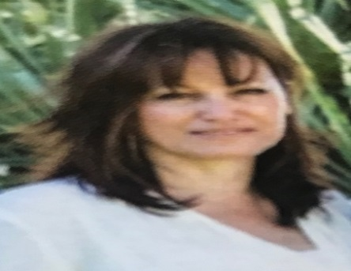
Elizabeth Figliuzzi
Psychologist MAPS
BA. GradDip Counselling & Psych. PGDipPsych. PGDipProfPsych

Elizabeth is a registered psychologist. In the last six years, the focus of her work has been on treating and supporting mothers and fathers who are suffering from anxiety and depression; experiencing adjustment issues; and dealing with grief/loss throughout the perinatal period. She is passionate about empowering mothers and fathers to step on the path towards conscious and confident parenting, helping them cultivate a deeper understanding of the personal and interpersonal aspects that contribute to their challenges at this time.

Becoming new parents can be a very stressful time for couples, fraught with not only the intimate partner issues, but changing identity which impacts the couple.
Elizabeth is highly skilled at providing individual therapy that is aligned and relevant to the client’s needs and growth, envisioning for them a healthy future.

Client Comments:
Liz is the best Psychologist in the world – I’ve seen a few.

When I speak to Liz, it is like talking to a wise friend.

Your understanding and knowledge on postnatal depression is calming.

You have made a big difference to our family.

I never knew my child needed that.

Thanks for saving our marriage.

You can contact Elizabeth directly on:
E. liz@fullyhumanfullyalive.com.au
M. 0499 870 011

Page 8

Contact Us

To make a confidential enquiry or to request an initial chat over the phone or to book an appointment:

Email: info@fullyhumanfullyalive.com.au

Or

Text: 0419 000 000

Or

Call (02) 9705 0065
We will respond to you within 24 hours

We look forward to working with you

