- Examples of symbols (4 to be included to match company name)
– you might have more creative ideas



Australian (one of only)


Vocational

Skills


Education

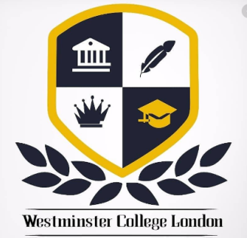
2. Examples of logos with text and symbols – you might have more creative ideas
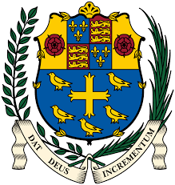
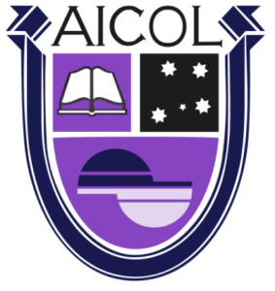


3. Examples of color schemes

4. Text to be included
AVSE-TESOL
Australian Vocational Skills & Education
Since 2009

