A drawing of Nipsey Hussle posing as Malcolm X with a rifle while wearing his Malcolm X chain with the words “I AM MALCOLM X” surrounding the image in block letters. Nipsey should be wearing a suit like his shirt below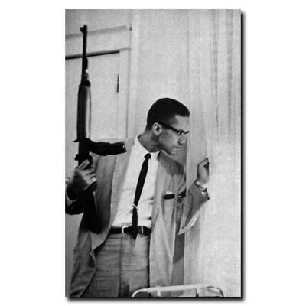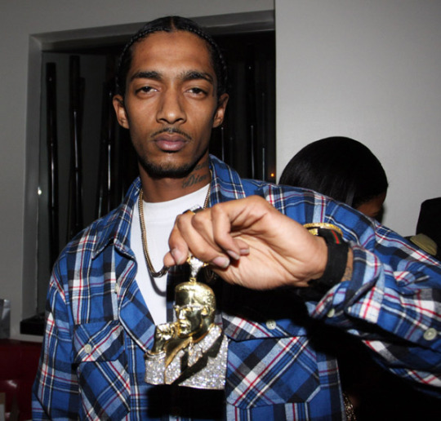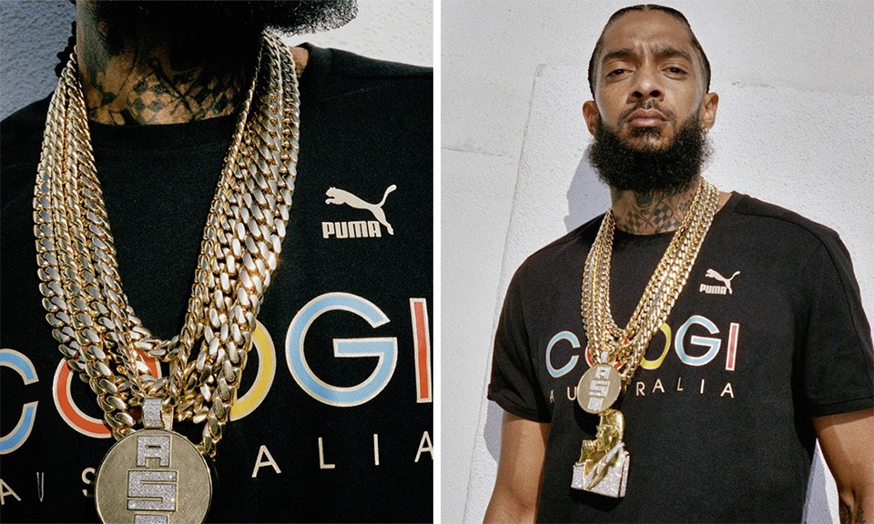Looking towards you instead of the window. With a beard like in the pic above.

