A logo for a website that will document a peaceful political movement.
The logo will include the Arabic text “ثورة أكتوبر” as the key element. This size should take some 50% of the logo size or more. The color theme is mostly red and black, some green, resembling the flag of the country of Iraq
Icon to include 1: the auto rickshaw picture below should be symbolized. Of course, you are designing and including a symbol of that not the actual photo. Please google this to get a better idea. This should take around 20% of the loge design or lese, but yet visible. This auto rickshaw symbolizes the way youths were transporting injured people during the movement.
Icon to include 2: women have played a big role in this movement. The picture below is of a woman that was giving napkins for free in the streets to protestors who were being shot by tear gas canisters and needed the napkins to wipe their eyes. I want a symbol (Of your design) of this woman, with her exact facial expressions, while she is giving away napkins. This should take around 20% of the loge design.
Icon to include 3: a symbol design of the building which was mainly used by the political movement. The picture of the building is on the bottom. This could take no more than 20% of the design. Please preserve the key features of the building in your design
Goal of the Logo: it should give a feeling of revolutionary by youths against poverty. It should include a fire torch symbolizing a revolution. The logo for instance, could also have a hand fist, since this usually symbolizes the will of people
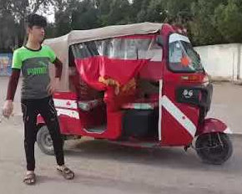 | 