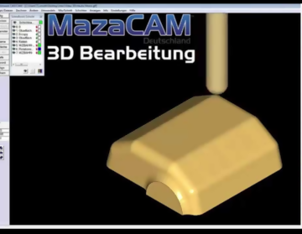
3D Machining
Machine 3D-surfaces
Editor
Programming Mazatrol on the PC instead of tying up the CNC
Solid- Verification
Simulate cutting parts
See problems on the computer before it goes to the shop floor
3D Machining
Machine 3D-surfaces
CAD/CAM
Efficiently Program Mazatrol
+ G-Code in one system, from CAD-files or drawing
Control Conversion
Convert programs between different Mazak generations &
Re-purpose existing Mazatrol programs onto different Mazaks
3D Machining
Machine 3D-surfaces
Data Management Store & Manage Mazatrol Programs

