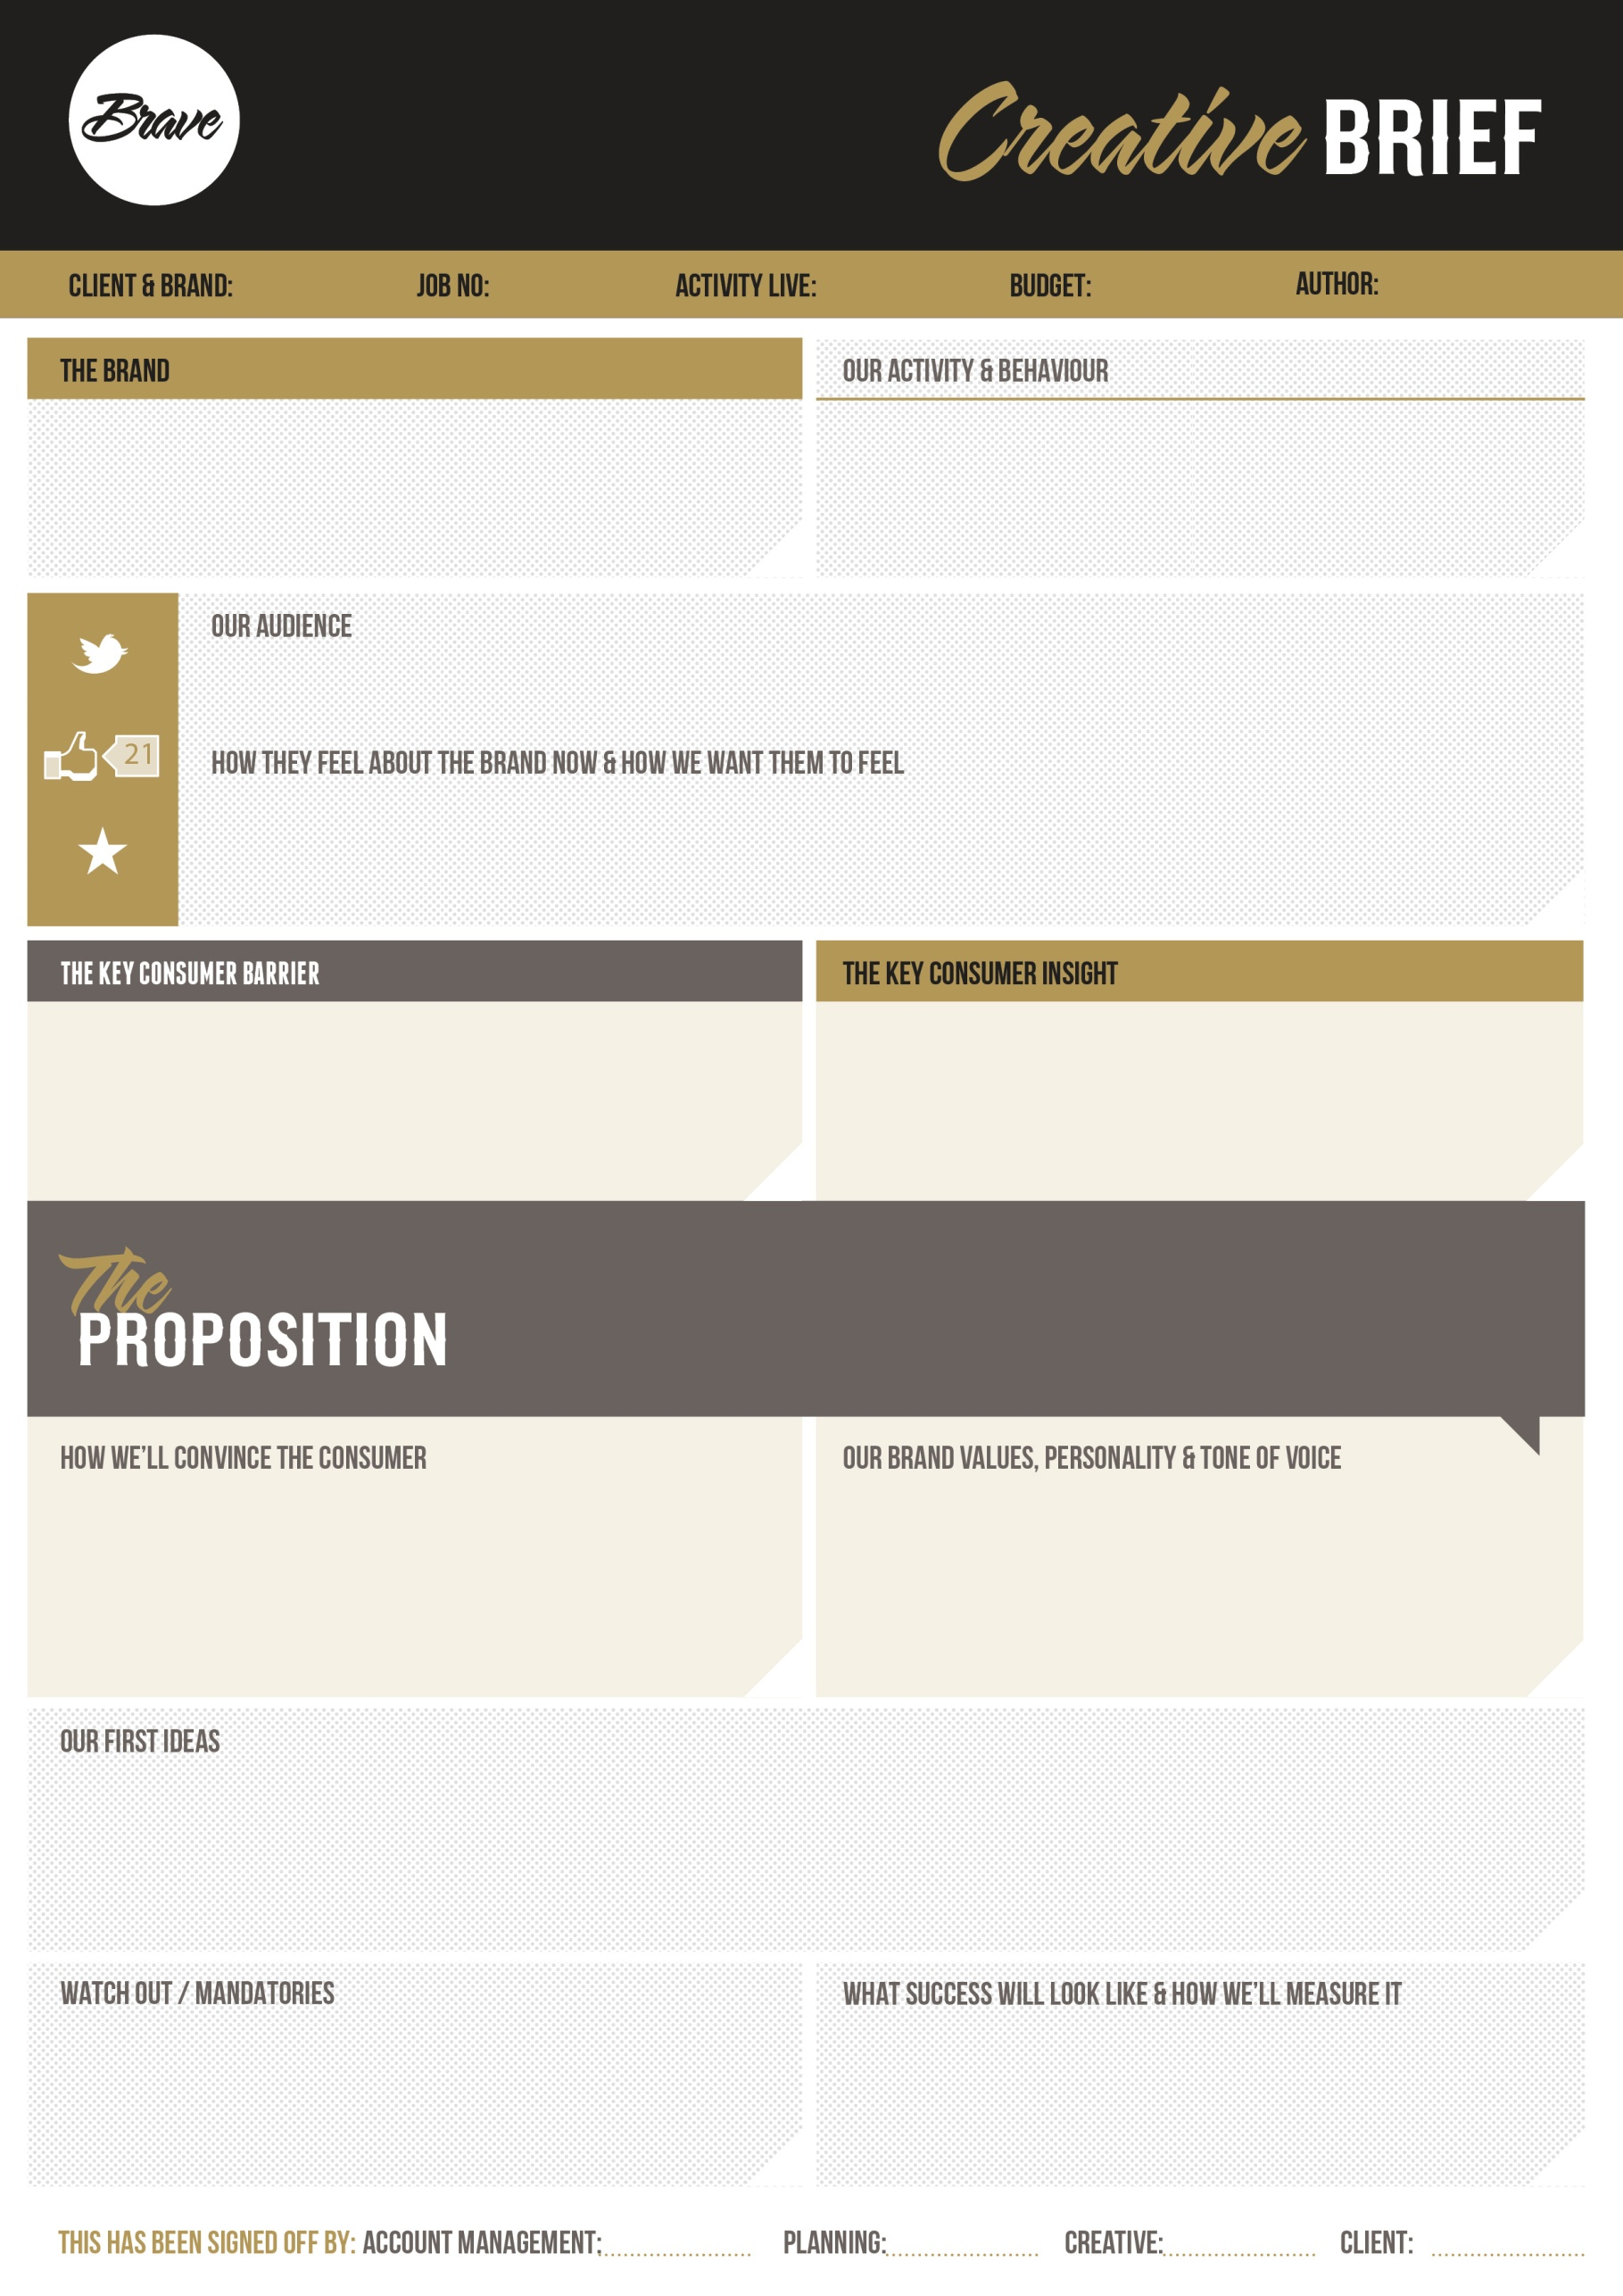
Lives and work are changing in the rapidly evolving digital world – a lonelier, more isolated society is emerging with individualism, autonomy & personal responsibility at its core. We’ve never been more connected but further apart. We will educate/inform for a wealthier economy – leading to a happier, healthier and more productive workforce

12345
12345
12345
12345
A dynamic organisation with an experienced and passionate board, stakeholders & employees who are aligned and working towards the shared purpose, vision and mission of the company. All embracing and supporting the ‘always learning & developing’ mentality of the business. This will be reflected in 1sixeight being the leading mental wellbeing solution in the UK with global reach and partnerships

The fear and resistance to mental wellbeing is huge. It’s also challenging to appeal to all, so being strategic in our messaging, launch and approach to market is critical, ensuring our POC is engaging, compelling and impactful. Ultimately, we want to embed mental wellbeing into the daily lives of the nation with ease and autonomy – avoid clichés - focus on science led
.
The ultimate confidant available 24/7, exclusively for you and about you. Built around your specific needs, always on, always learning. We will take the time to really understand you/listen = lifetime provision based on your personal needs and requirements.
It’s about autonomy, awareness and access to effective directions with lifelong support. We are building an ecosystem (space) plenished with mental wellbeing resources & communities to support people accessing the necessary tools for increased insight to live a happier, healthier and more productive life.
Confidential/insightful/invested/breaking silos
Smart, engaging, intelligent and easy to use. Confidentiality is crucial. A focus on autonomy, happiness and optimising personal performance rather than coping with stress. A sense of confidence & personality to assure our customers, making life better/easier, building a community for your life – a real gateway to a healthier, happier and more productive life.
(Reference: brand guidelines, brand website, Facebook, current ads)
1sixeight is an effective solution to employee wellbeing. As a human -centred product it will provide employees access to 24/7 confidential support and bespoke recommendations enabling them to have insight and autonomy over their mental wellbeing. 1sixeight also benefits employers via regular data, insights and reports, which when applied can further support engagement and delivery in the workplace. Increasing productivity, reducing burnout, less illness days etc – sciencifically backed

When life becomes too much. I don’t know where to go, what to do or how to begin. I’m not depressed & don’t need antidepressants. 1sixeight enables people manage their own mental wellbeing through comprehensive wellbeing measurements and the provision of personalised direction & support. The app adapts in real time to new data, info & insights. It provides access to digital tools, performance tracking metrics, accredited partnerships & socially connected tribes

A ‘hot topic’ & growing market saturated with generic short term, surface level solutions that negate the individual needs of the employee. Concern re costs, deployment & capacity to measure impact. We need to be compelling and creative, adopting & developing as tech advances, as the needs of employees & employers change, and as direct competitors emerge. We listen & learn 24/7, we personalise, support individually & via communities, provide proven effective solutions
They don’t know us, but we need to be a rock-solid product (reliable, data-driven, scientifically validated, engaging, solution focused, user friendly, trusted, self- learning) with an innovative holistic approach to mental wellbeing & personal performance. Our motto is ‘manage, not cope’ – a daily ‘check-in’ to reflect on your current state (how your feeling,) is as crucial for mental wellbeing as food is for energy!! We provide personalised, engaging and effective directions, with intuitive & interactive design supporting a more productive, autonomous and happier life – working together for positive impacts/outcomes.
Employees between 25-45years of age, across all industry sectors, basically everyone as we all have mental health
CEO’s and HRD’s and the people in these organisations that need help and support – these are our buyers
We have a name and ambitions, but we need to be building a brand, a creative platform to engage our partners and new customers? Brand identity and visual style, digital materials, ETC. Brand guidelines, attitude, TOV… we want to be seen as progressive, human and ahead in all aspects of digital mental wellbeing and also how we deliver our brand and our varying messages

12345
12345
12345
12345
12345
1sixeight is a scientifically validated wellbeing app designed to address the growing cost of mental ill-health currently facing UK employers - estimated between £38 - £61 billion a year. Based on psychologically informed data, this digital product will transform UK mental health through intuitive design and modern AI technology, by providing employees with access to confidential personalised on-demand support.

